Bank of England

Inflation Repor t

February 1994

Inflation Report

February 1994

Recent dcvclopments in inflation

.1 Retail prices

1.2 Output prices Domestic deflators

##### 1.4

*Boxes*

Core inflation 10

Summary

*Removing indirect* free *Jruin* f/ie *RPI* Food prices and the RPI

1. 4Ionetary policy 12
   1. Money and credit aggregates 12
   2. Interest rates and exchange rates

2.3 16

Demand and output Demand

Overview Personal spending

Investment and stockbuilding 19

###### Overseas trade 20

Fiscal developments

3.2 22

24

The labour market 25

Nominal and real earnings 25

Unemployment 25

Employment 26

Exp 26

* 1. Productivity 27

###### Summary 27

29

t pr 30

5.2 Profitability, margins and mark-ups Export prices

Summary

36

* 1. The Bank’s medium•term inflation projection 36
  2. Private sector inflation forecasts
  3. Uncertainties affecting the projection

39

Printed by Pork Communications Ltd

e s»x or England 1994

ISBN 185730 062 9

Summary

**RPIY** inflation, which removes mortgage interest payments and the impact of higher excise duties, has fallen by more than a full percentage point since September. Narrow money, M0, has continued to grow erratically, at an annual rate above its 0 —4% monitoring range. Broad money growth increased to an annual rate of 5.4& in December. These data are consistent with a continued recovery and further balance sheet adjustment by indebted firms. Non-oil **GDP** increased by 2.ldc over the year to the fourth quarter. The output gap is likely to narrow as demand increases. Investment and stockbuilding are likely to contribute more to growth as the recovery continues. As yet, there has been little sign of upward pressure on nominal earnings growth. Import costs are unlikely to generate any inflationary pressure. Combined with continued low growth of unit labour costs, this means that firms' profits and margins can continue to increase without necessarily pushing up inflation.

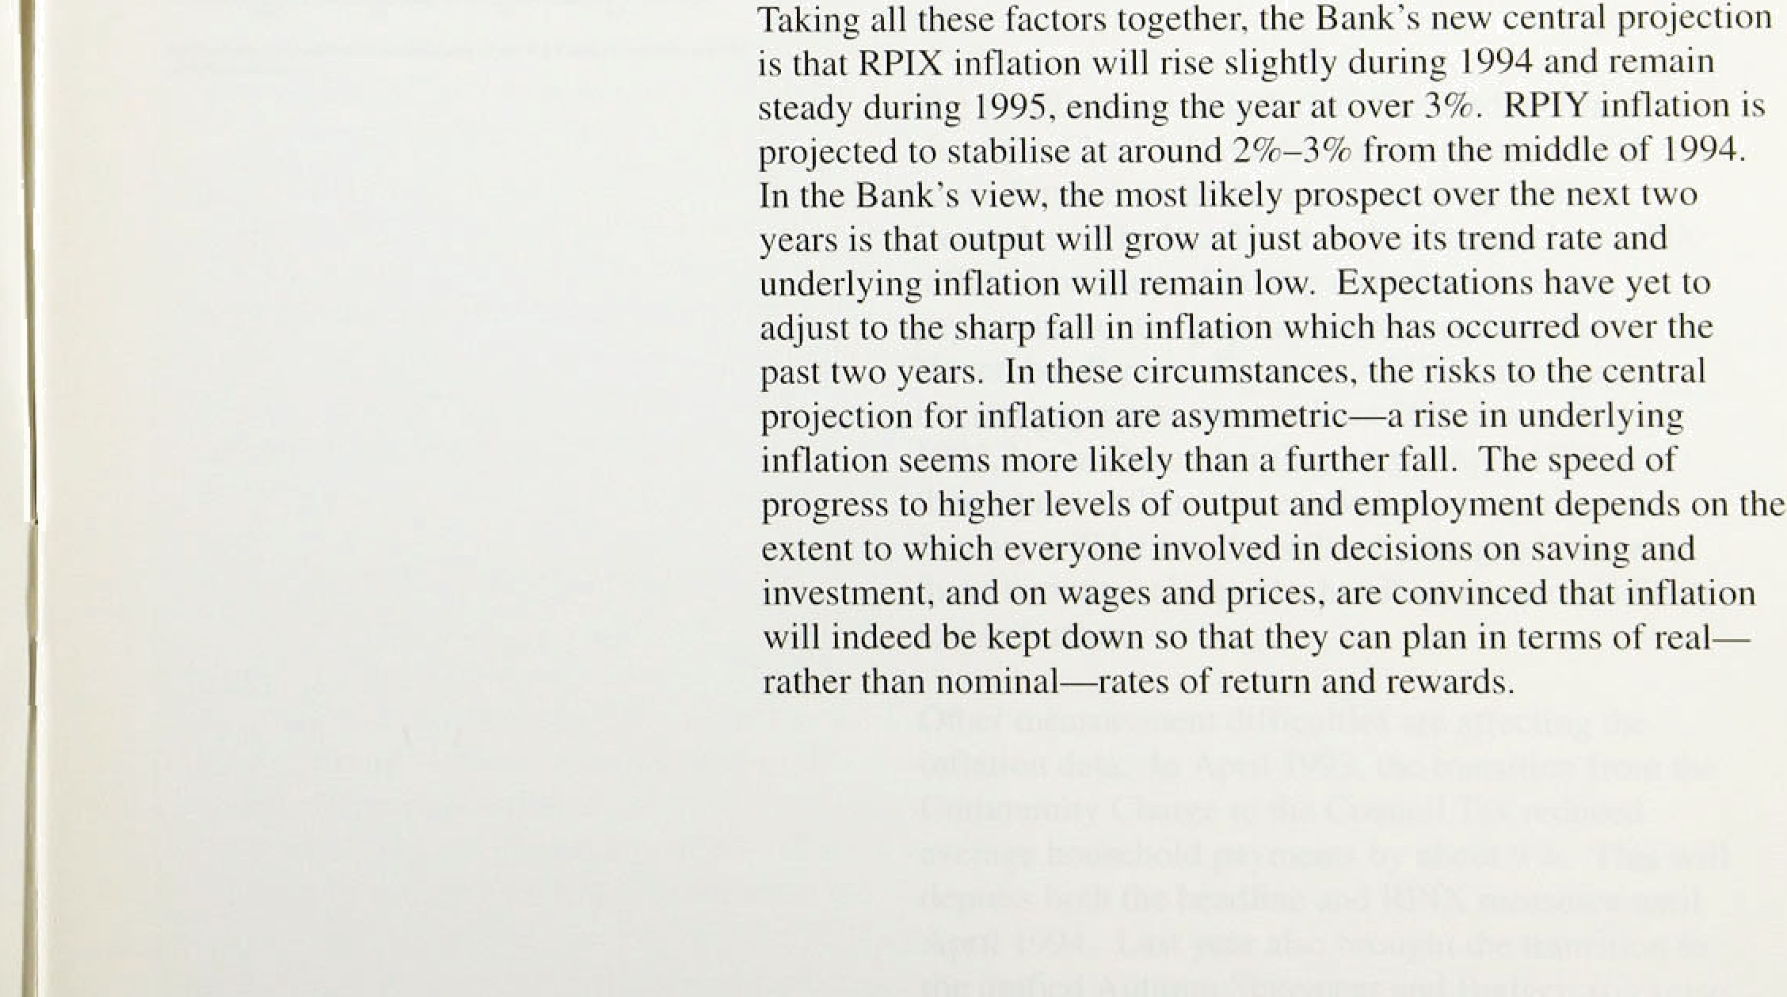



#### Retail rices

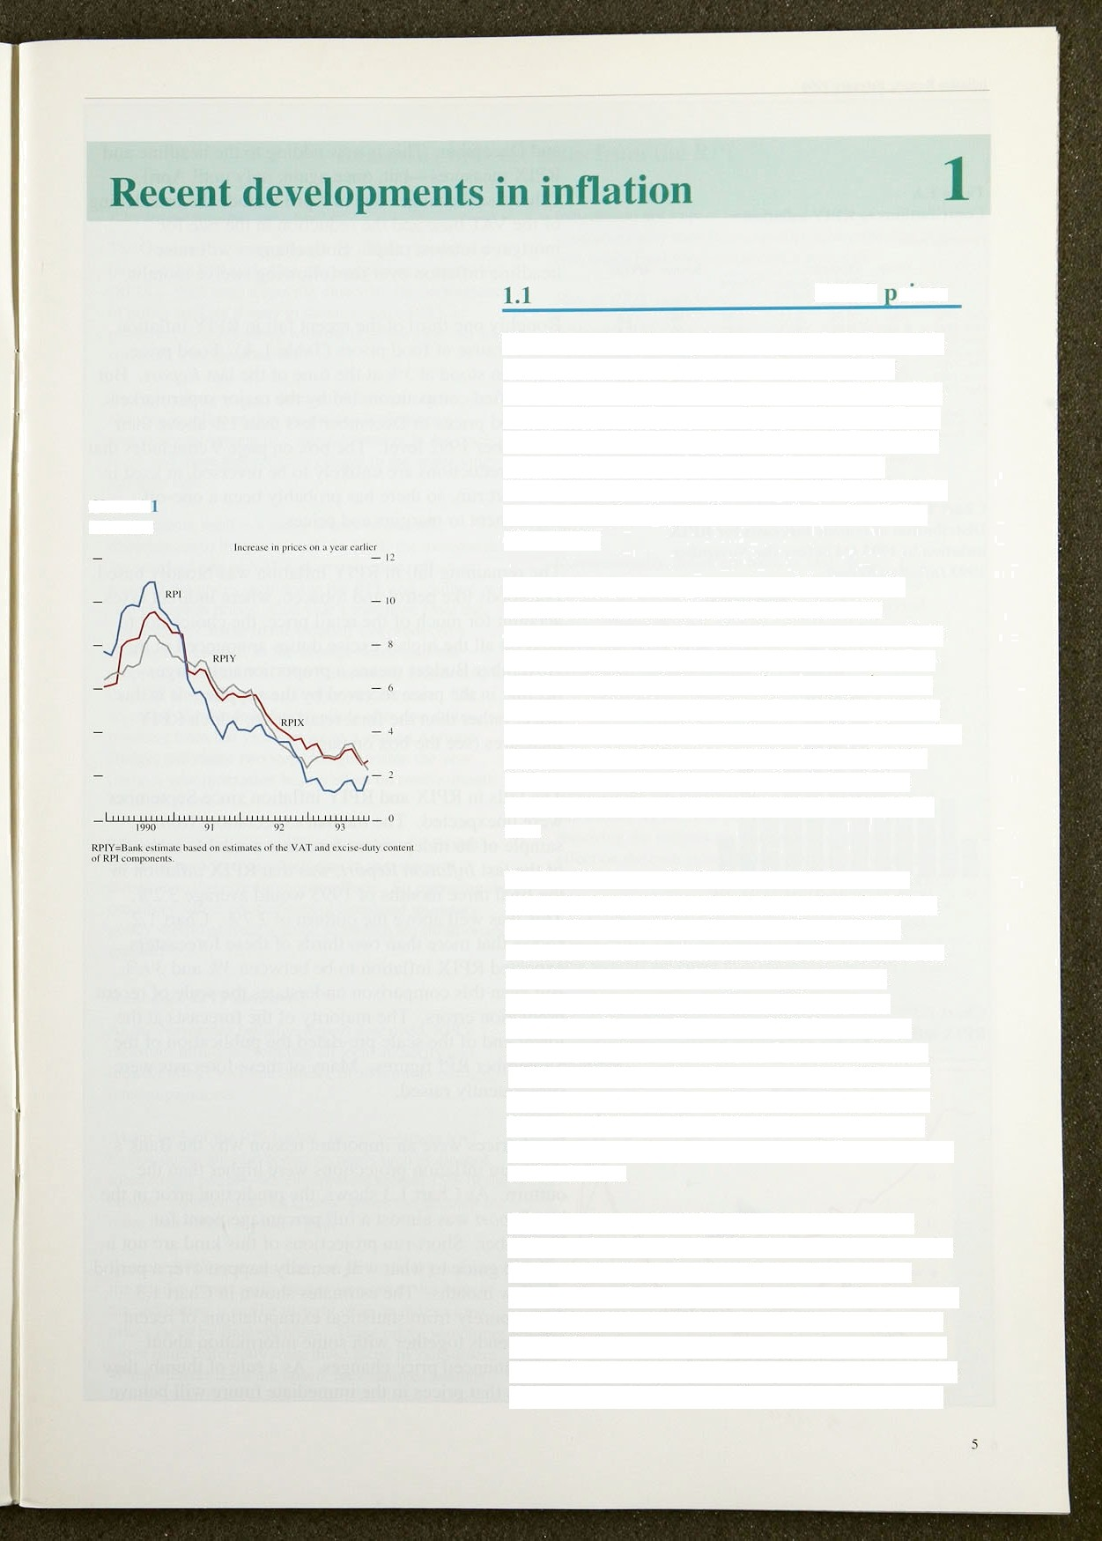

**Chart 1.**

**Inflation**

The Government’s target measure for inflation—the twelve-month change in the retail prlces index excluding mortgage intereH payments (RPIX)—has fallen sharply since the last /n/Jaii‹›ii *Reyort.* Three months ago, it had risen from 2.8% in June to 3.3% in September. But it fell in both October and November, to 2.5%, before rising slightly to 2.79c in December following the increases in excise duties (Chart 1.1 ).

Over the next few years. a series of increases in indirect taxes means that RPIX inflation will overstate underlying inflation in the economy. So it is important to examine changes in a price index— RPIY—which excludes not only mortgage interest payments but also local authority and indirect taxes

(see the box on page 7). At the time of the November *Reyort,* RPIY inflation was a little higher than the RPIX measure (see Chart 1.1). But it has fallen sharply since and, at 2.3%, is now below the RPIX rate.

The headline rate of inflation, the third measure shown in Chart I.I, reached a low point of 1.2' r in June. Since then it has risen, reaching I.97c in December. The headline rate has been below RPIX inflation because of falling mortgage interest payments, but the gap has narrowed since the November *Reporf.* For most of 1993, mortgage interest payments were at least 207a lower than in 1992, but in December they were only 11 % lower than a year earlier; the equivalent comparison for January will be smaller still. As the gap between these two rates closes, the headline measure is likely to rise further.

Other measurement difficulties are affecting the inflation data. In April 1993, the transition from the Community Charge to the Council Tax reduced average household payments by about 9%. This will depress both the headline and **RPIX** measures until April 1994. Last year also brought the transition to the unified Autumn Statement and Budget, so excise duties were raised twice, affecting the **RPI** in April

In1lati‹›n Report: Fet›ruiiry 1994 _

Tahle I..•S

£”‹›ntrihutinlys l‹› kPI1' it flati‹›n •›

and December. This .is now.add!ing..to!ihe headl.rue!and RPIX. measures—but,.once again,!.only until April.

Other fiscal chahges du’e in.April. i.nclude.the..broadening of the VAT base: and the reduction in the rate for

“ “'*’* * mortgage interest relief. Both chan:ges will raise  inflation 0over the following twelve months..

Roughly one third of the recent fall in RPIY inflation was because of food prices (Table 1.A). .Food price inflation ,stood at 3% at the time of the last *Report.* But intensified competition, led by the major supermarkets,



|  |  |  |  |  |  |  |
| --- | --- | --- | --- | --- | --- | --- |
| k1;v. IS93 | (1.88 | 0.26 | ‹\.17 | (›. 13 | | .'JI} | 2.g |
| fi epl. 1093 | 1.69 | fL•i6 | t1.2(1 | 0.'_* I | 1.71a |  |
| tact. 199 ? | 1.27 | 0. 38 | 0.ll3 | 1). 2 I | 1.60 |  |
| Nuv. 199 i | 0.88 | 0.27 | -0.tl7  "" | 0. 18 | 1.6f;  ' " | 2.6  2 ' |

"'”'"""“'“""”'“ "' ”' "““'" left food prices in December less than 1% above their

December 1992 level. The ,box on page 9 concludes that

recent reductions are unlikely to be .reversed, at least in

Chart 1.2

**Gistribution** of outside **1’orccasts for** RPIX inflal inn in 1993 (jJ before the November

the short run, so there has

adjustment to margins and prices.



been a: one-off

1993 *friflatioii Report*

— -s





thart I.3

RPIX **inflation** prejectiens and **outturns**



—4

The remaining fall in RPIY inflation was broadly based.

For goods like petrol and tobacco, where indirect taxes account for much of the retail price, the choice not.to pass on all the higher excise duties announced in the November Budget means a proportionately larger decline in the price received by the supplier. It is this prlce, rather than the final retail price, which RPIY measures (see the box on..page 7):

The falls in RPIX.afid R!PIY inflation since. September were unexpected. The median expectation, from a sample of 36 independent foiecast3 ava!iIab1e.at .the.time of the last *Inflation Reyort,* was that RP.IX..i.nflation!.in the final three months of 1593 would average 3..2%.

This was well above the outtum. of 2.7%. Chart .1.2 shows that more than two thirds of these forecasters expected RPIX inflation to be between 3&o an‹i 3'/i%. But exen. this comparison understates:the scale of recent predi'ction .errors. The majority!1ofi tlie forecasts at the lower.end of the scale pre-dated the publication.of tlie September RPI figures. Many!.of these forecasts iced subsequently raised:

:short-nin inflation Ations vwere.higher.:iha:n the outtum As!Chart 1 3 shows the préñiction error in the



.last.Aeport was:almost a full percentage point for.’ November. !Short-iñn‘projections of this kirid'are not:a reliable gyide to what will,actuaily happen over.a penod of few:months. The estimates shown in Chart 1.3 derive purely from statistical extrapolations of recent ptice trends together with some information labout

pre-announced price changes., As a rule of thumb, they assume thttt prices. in tire immedi!ate futiire will,.tiehave



/?‹•c•‹•/i/ Plc' '‹•/z›/z/z ‹•›zrs *iii iz///rHir* H

### Reraoving indirect taxes frora the:RPI

**Wny** inren/ **atiofâer** m.pa4iire*

The Government’s targét range fpr.iiiflation, is.!defined in. terins of tire RPI excluding inortgage interest paymehts

**.(RPIX).** Witfi such a speci'fic objeétive; the pérformance.



The mâin **purpose.!is.** fo.distinguish between those changes in iiiflation.that are. the. result.of either a. témporary movement or a! step adjustniént:to the price level, anfi tliose,thaf. reflect a change to the underlying 'inflation rate.

Government!itself is a inâjor.source.of.one-off disturbances to .the pr’ ice 1eve1. 1n 1991, Ihe ’ increase’ in

.the standard rate of VAT had an immediate effect on many of tire pyices include‹i in the RPI, and resulted in a step change in prices. Last year’s transition. from the Cowuni Charge to the Council Tax .produced a sirni.lar step change,.as .the average household bi!1

.drqpped. by.around!. 9&c. The forthcoming broadening o1 theo VAT. base will. cause a further step. increase. The

so-,called 'double indexation’ effect. of excise duties resiilting from ,last year’s .move lto a unified Autumn Budget will cause .two .step changes within the year

!(oncma-year indexation. has .no. effect on twelve-month

lll(1iltlOn' £dtfS):

These step changqs inay.affect measures of inflation in the sh9rt run ih.a way,which runs.in.the Opposite direction to their medium-term leffects: So.removing the transitory, ñirect price effects of fiscal and rrionetary policy should proivid‹i a g.uide.to,unfierlyiiig inflationary pressure.

***What dogs RPfY measure\****

may decide not to pass on ihe whole increase. ‘Fi.8;il: consumers may, then face a smaller-than-ex rise,.while.final.suppliers.accept:a price. fall. .



straightfo aid:.: Identiifying and.removirig exrise duties. and VAT .fiorñ the component price series âhould„ striclly„ be done.at a leveJ of ;Jisaggfigalion..which... reveals the range of variation .in duties añ‹i .VAT status, RPIY is calculated using a.moti.agjregateñ approach; bul the same basic. procedures, for identifying arid removing taxes from component prices and. for reweighting the adjusted seri s Nithin'the new infiéx, are applied.

Conventionally, duties are fixed in cash terms. This means ihat the published price indices must firxt be expressed as cash prices, by applying a base-period price. The cash value of duties can then be deducted, and a new price index computed. The effect of the calculation can be striking. In January 1990, a litre:.of 4-star petrol sold at around 4 I p, of which 26p was.duty and VAT.. Four years later, the price had risen to about



56;›-a 36°/r increase. But .if indirect taxes are excluded, the supply price rose by only 10%.

Reweighting the adjusted price series is a key part of calculating RPIY. The petrol example shows that removing the indirect tax component can have a big effect on the cash price. In calculating RPIY, we have adjusted the weights of the component seriés to reflect these changed cash values. Items .such as {petrol.have a.

.much-reduced weight, while .for iteiñs such as.food— where only a small proportion is subjéct to VAT ther riew weights are larger thari in the .stantiard R8I basket:

The chart compares’RPIX and RPIY .iiJlation since

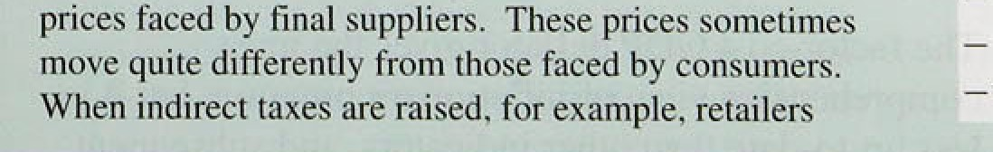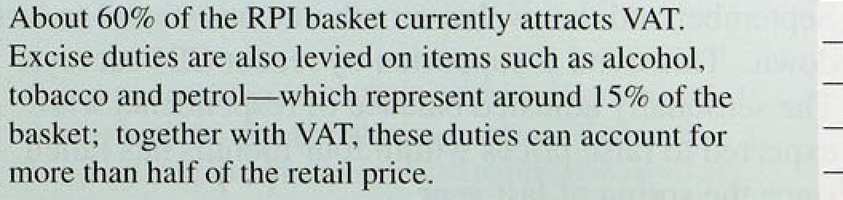



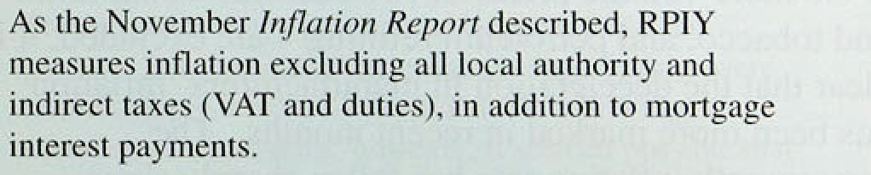

l‘979.





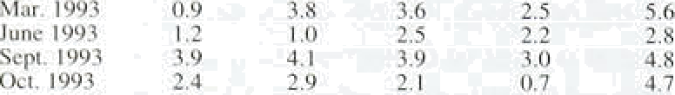RPI RPIX RPIY €i‹›nds Service.s Dec. t‘J*72 I .fI 4.TI ñ.g 3. I ñ. I



(a n e in rite laicst month '›n th rcc months curlier. .*a«›n«lI y iuljus tell unii

h tl .f F ..p .J „ ... +,.,

t’hart 1.4

**Protiucer output prire inflation**

as they have done in the recent past, with some allowance for the normal seasonal pattern. When inflation is changing rapidly, this assuiñpfiori is unrealistic. But the value of such projections does not depend primarily on their predictive povier. .Sh.ort-run statistical projections provide a ‘benchmark’ against which to assess the ‘news’ contained in subsequent inflation figures. At the moment, the comparison suggests that downward pressure on .inflation,remalns somewhat stronger than was apparent three months ago. In part. this reflects new pressures in foñd.retai.I!ifig, but the earlier assessment may also .have exaggerated the. scale of post-sale price rises in the late summer.

Table I.B shows how short-run measures of inflation— the change in prices over three 'months have varied during the past year. These can give an early .indication of a trend change in inflation, but they:are sensitive to changes in seasonal patterns and to temporaiy disturbances. After falling sharply in ,the early summer. they appeared to indicate some rebuilding of inflationary pressure following the summer sales, .but this has:once more been reversed. Over the past tivo inofiths. thñ prices of goocls: have ñeen falling..

#### 1 2 O ces

The twelve-month change in.output prices rose to 4.0% in December,. mainly because.ofihig.her!excise ‹duties announced in .the. November Budget (Ghan.1:.4).. In .the previous moiith„ it ha‹i faJleh sharply, to 3.6%, as .the increases in. petrol prices a year earlier ‹dropped: out of the calculation.

" “" If the more volatile prices of two sectors food, drink



“"”?, and tobacco, and.péUo1eum refining arel Excluded; ’it.is clear that the deceleration.in mañufacturers! inflation has ñeen more inñrkeii in recent months.. ’the

* three-month inflation.rate. has.fallen sharply since.:’

, September and the.twelve:-month.raté has started!to turn.

down., This trend.,is supported by récent CB!I surveys.

The seasonalil.y adjusted.balance.of respondents.who

› expected/.to raise prices withi!n four months has fat.len

, sincd the! spring .of last year.

# Domestic deflators .

The factor-cost GDP deflatop gives the.most comprehensive view of inflationary pressure, but it is **less .up-to-date** than!other..indicators,.and subsequent

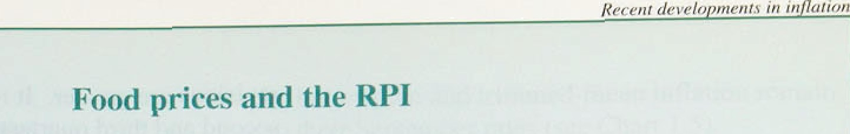

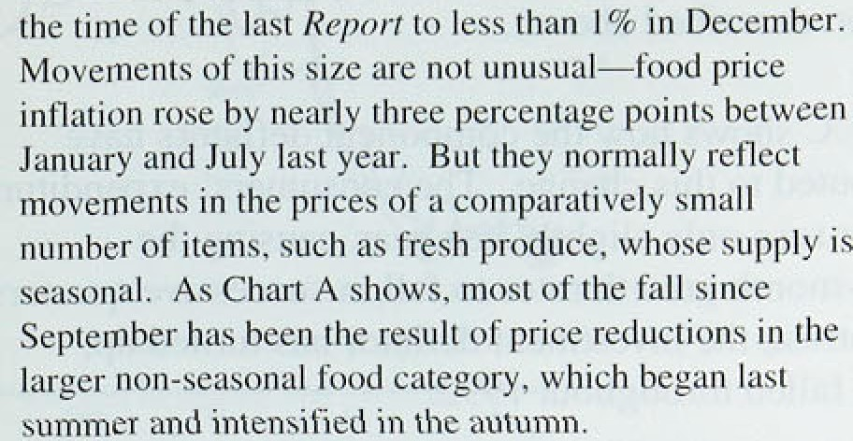

ori..a sim'ilai.narrow'. range of::own-label pniducts in a

:diFect response.:to this mover

The'.competition: for market share mqans that Ie .lower prices. are Ji:kel.y. to’.coritinu : ’As ygt, iliscount stores occupy,.a relatively .small share of the;.retail foo,d market.

.8.ut they âre: expanding„ and are: being joined by symi'1ar ventures patented ñ.y°exisiing medium-sixed supermarket chains, The .pressures on .the market leaders are

reflected i'n the performance over the past year of their shares, ciompared.w.ith the .F'T-SE-A All-Share index (see Chart B)..

Churl .fi

**F‹›‹›d** t›rices

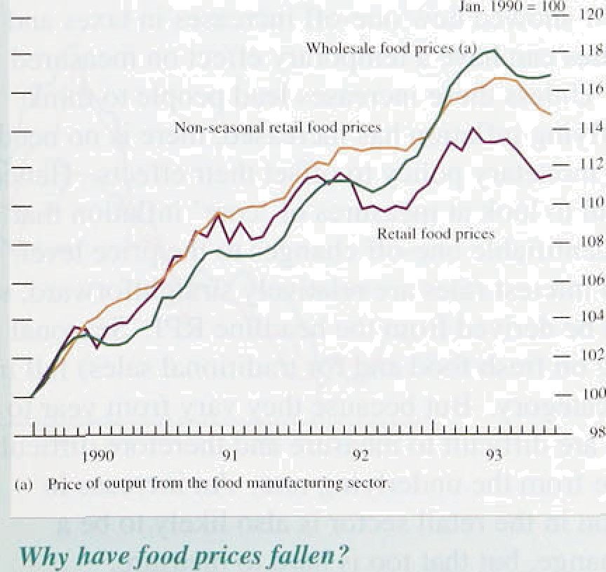



Non-seasonal fooñ price .reductions of this size and

duration .are unusual. In ceñt. years, non-seasonal prices Because the .superrriarket promotions have concentrated

.have. usually.been reyiqwed.in the i»!er:and spring, and on.own-label products. theii iinpa?t..has iprobabl:y not yet then hélct broadly stable: threugh the summer. and.au'tumn. been .ful.ly refiectâd in the inCatioii measures: Producers

The:.increases in the'.firs't,!half pf lit year fitted this

**.pattern: !Because.** many agricultural support.prices:were: raised. sh ly around the.start of 19,93 followi9g. currency: re-aligiiments,:however; it:seemed possible that retail food prices. would rise fister: .Wfiy! fiid this not happen?

Competition 3n the footl-retail!tng industry has intensified.

of branded..products are reconsidering their price

* structure in the..li .ht of.the ihcreased ciortipetition, arid'.iti is..unlikely. that the competitive.changes.âre yet;compléte.

.In addition, .it takes:time .for changing.patterns of expehdituie—suéh as the..growing use of discount siores nd tire.Expansion. i›f own'-latiel sales to tie .fully reflected in. the official;'statistics.

sharply:with the onset of.important strut changes., . The contribution:!to'infiaiiorr.from non-.seasonal food The market leaders. hay.e continue‹i to:inyest.in neiv prices, is:therefore likely:to:be low for some.time: Tlie

:superStores; offering a wide .product. range away from price reductions seen so far will..hpfd measu.red inflation

.traditi‹inal town **centre.** sites: At the same time, a new dolwri un'ti'1’ they .drop out of the twelve-month cal'cu:lati0n

, g.roup .of disc.ourit!food!stores—many with **European.** or later this year. The pressure tliat **they have** generated

US parent.companies—.havq Entered the market; offering means that the price reviews occurring now and over the. a l!imited **mnge** of high volume, basic food **products on** next **few months** are. more .likely to **be biased towards.**

1s margins. The price.promotioiis std last autumn .further reStra.int. .If .that is so, food price.inflation may

**ñy the leading supermarkets** iñade large **price reductious** fall further in the coming months.





Perc'-niaCe sha ride s ‹›ii a y'ear carltef





Seasonally adju stcti Jv:irierl y gn»'t h rate s— l '19?.

() 3 un @* • tl: I tl.? -0.1 - I.4 •t i.2 tj.7 ()4 on Q \ tl 3 t l.l — 1.s I i.4 tL7

revisions are greater. It rose .marginally between thel second and third quarters of last year. Three inonths ago, the rate for the secsnd quarter was, put at 1.59r; this estimate mas been revise‹i to 2,89r:, The rate.has: risen to 3.0% in .the thir‹i quarter (which is consistent with the timing of the temporary pick-.up tn retail pricel inflation described above)..

Table l.C shows how the component deflators have contributed to this change. The consumers’ exp:enditure deflafor rpse only slightly last year, :causing the

twel ve-month growth rates to fa:11 in successive. quarters. By contrast, the .investment deflator has. turned up, having fallen thro,ughout 1992.

* 1. **Core inflation**

Section I.I showed how one-off increases in taxes and interest rates can have.a temporary effect on measured inflation. Unless these increases lead people to think that underlying inflation has increased, there is no need to tighten monetary policy to offset their effects. Hence it is helpful to look at measures of ‘core’ inflation that exclude identifiable one-off changes to the price level. Taxes and interest rates are relatively straightforward, so RPIY can be derived from the headline .RPI. .Seasonal effects (eg on fresh food and for.traclitional sales) fall in the same category. But because they vary from .year to year. they are difficult to measure and therefore diffieult to separate from .the underlying rate. An increase in competition. in the retail sector is: also likely to be a

one-off change, but tha( too is hard to imeasure..

Just as one-off increases in .the ,price level as a result of tax .changes do not require a .tighter monetary, policy .(as long as they do not generate!knock-on!effects), nor rn

at hp c e But relati.ve

Ines’ verdalnthetir , : n tlieyb

distinguished from „changes tn under1,yiiig inflation? One. approach (described' {n detatl' i!n the; May 1993. *Report)* is to use all the component RPI price series to : computq a medman:twelve-month change .for each period, thus giving. no weight to extreme movements i.n! relati.ve prices.. .A variant of this approach is to excl.ude. the,biggest price changes and calculate the average of the renaming changes. The result is called.a 'trimmed mean'.: Med;ian and tri.mmed-mean inflation track RPlY inflation qu:ite closely in the longer nin:.. Both'were:wel:l be:low RPIX..and ltPIY):nflatiori at tlie time of:the last

be *port:* S.ince then,.RnIX.and RPIY rates have .fallen

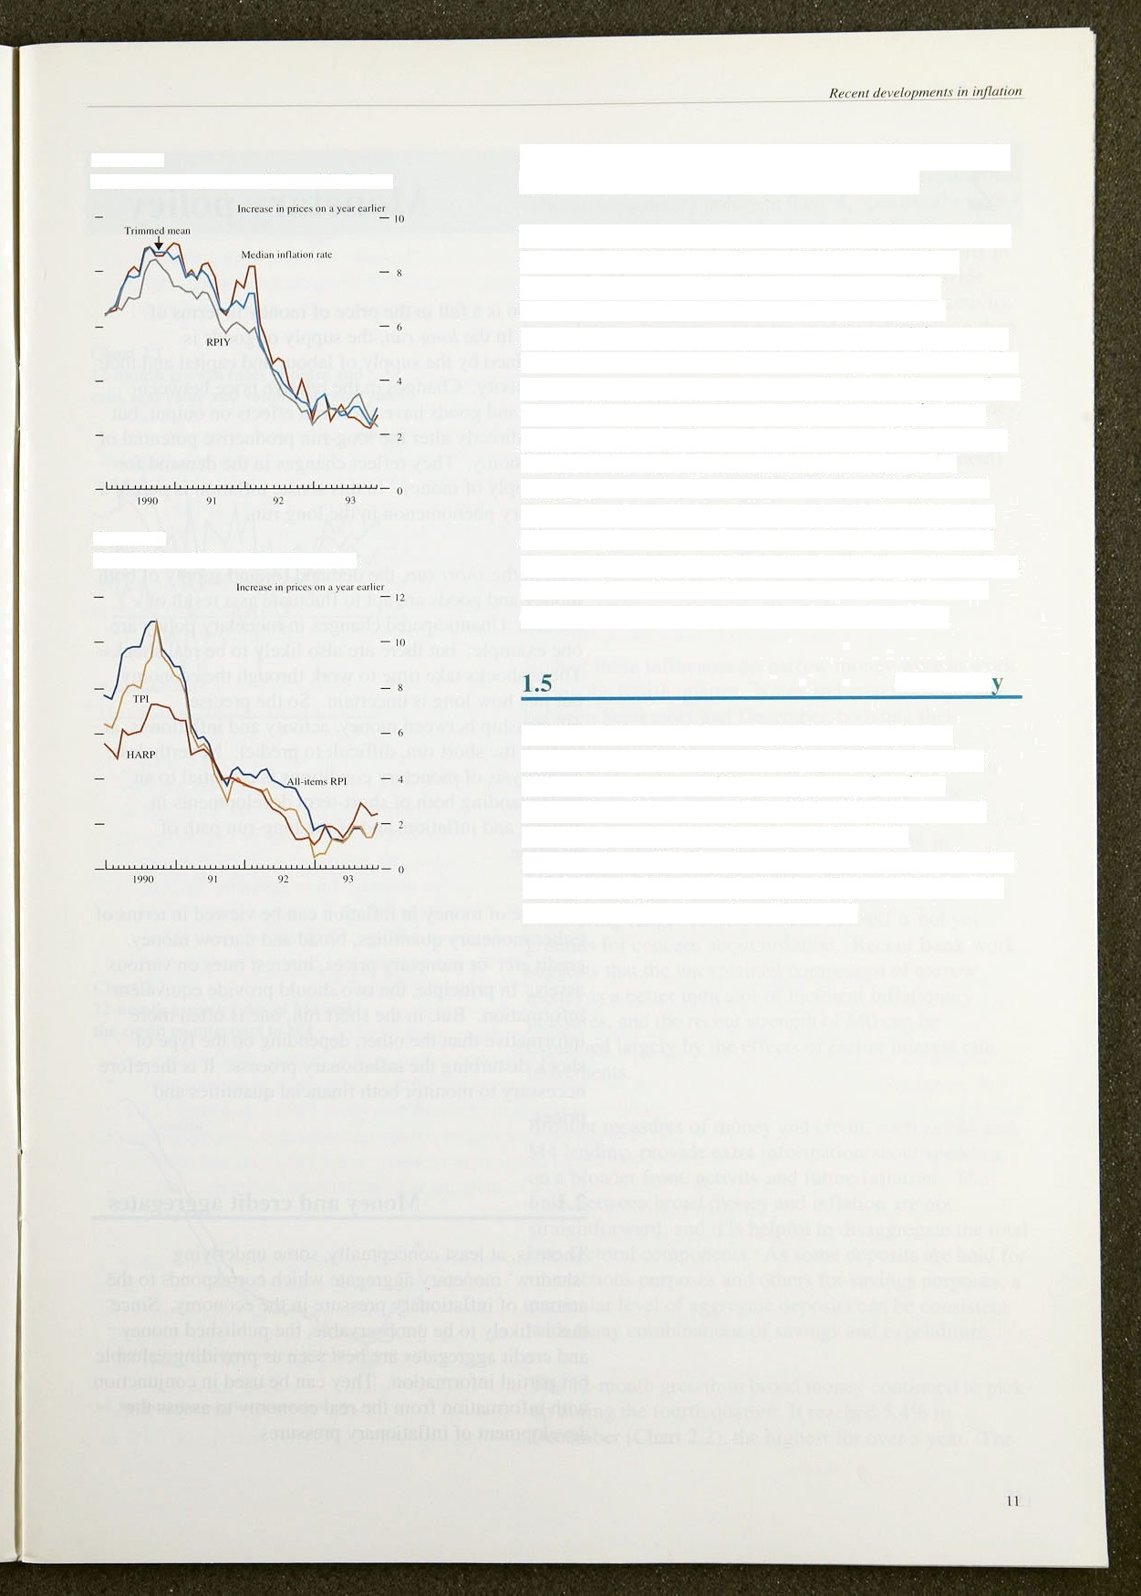**Charl 1.5**

**Alternative measures of ‘core’ inftati‹in**

Chart J.fi

**RPI, TPI and HAMP inflation *rates***

sharply, but median and tri mmed-mean inflation remain close to their September rates (see Chart 1.5).

The treatment of housing costs in the RPI has long been debated. The housing-adjusted **RPI** (HARP index) replaces the mortgage interest component of the headline rate with an estimate of the user cost of housing. The Halifax house price index, which appears

in the user-cost measure, has been rising gently since the first half of last year. By January, it showed house prices were I.2% up on a year earlier, but mortgage interest payments in December were 11 % lower. This accounts for the difference between HARP inflation and the headline rate. The Tax and Prices index (TPI), which adjusts the headline RPI to compensate for changes in direct tax, continues to track the RPI. The two should remain close together until April, when the TPI will start to move above the headline measure. as the direct tax changes announced last year begin to take effect.

Sumnnar

**RPIY** inflation, which removes mortgage interest payments and the impact of higher excise duties, has fallen by more than a full percentage point since September. About one third of this fall is because of stronger price competition among the major supermarkets. This has brought about a sharp reduction in prices which is unlikely to be quickly reversed. The rest of the fall has been broadly based.

’2 

Inflation is a fall in the price of money in terms of goo‹is. In the long *run,* the supply of goo‹is is determined by the supply of labour and capital and their productivity. Changes in the relative price between money and goods have short-run effects on output, but do not directly alter the long-run productive potential of the economy. They reflect changes in the demand for and supply of money. In this sense, inflation is purely a monetary phenomenon in the long run.

But, in the *short run,* the demand for and supply of.both money and goods are apt to fluctuate as a result of shocks. Unanticipated changes in monetary policy are one example; but there are also lihely to be real shocks. These shocks take time to work through .the economy, but just how long is uncertain. .So the precise relationship between. money, activity and i.nfl:ation is, at least in the short run, difficult to predict. Nevenheless, an analysis of monetary conditions is .essential to an understanding both of short-term developments in activity and inflation, and of the long-run path of inflation.

The role of money in inflation can be viewed in terms of either monetary quantities, broad and narrow money, credit etc; or monetary pri'ces, .interest rates on various assets. In principle, the two should provide equivalent information. But, in the short run, one is often more. informative than the other, depending on the type of shock disturbing the inflationary process. (t is therefore necessary to .monitor,both financial quantities and prices.

2 Mo e nd d e ate

There is, at least conceptually, somé underlying ‘shadow’ mpnetary gggtegate iwh.ich corresponds!to the amount of’inflatinnary pressure in.thé.econo'my. ! Since this: is likely to b.e‘unobperiable, the published.money and/credit aggregates are best seen! as.providing valuable bit partial intonation. They can be tised in conjunction with. information horn the real economy tp assess the d’evelopment.of idflatfonary **pressiires.**

Chart 2.1

**12-month growth rates of notes** and

coin, **and value and** volume **of retail sales**



-:- —..2

'— — 2



1980 91 92' .9?

**Charl 2.2**

**lfi month** growth **rates** of M4 and

**!the ssedit counterpnrt. to** M4:





Monetary quantities are particularly useful guides to shorks on the demand side of the economy. In part, this is because monetary policy in the UK operates through the control of short-term money-market interest rates, leaving the quantity of money to fluctuate with shifts in demand. Monetary aggregates can therefore provide corroborative evidence of trends in demand and activity. Indeed they often give more up-to-date information than

those statistics from the real economy itself.

One example of this informative power is narrow money, M0. Because it is demand-determined in the short run, M0 (and, in particular, its ‘notes and coin’ component) moves quite closely in line with measures of cash- financed spending. Narrow money is also affected by changes in interest rates, since these alter the interest forgone by holding cash balances. (The determinants of narfow money are discussed in the article on pages 46—50 of.February's *Quarterly Bulletin.)*

Both of these influences on narrow money were at work during the fourth quarter. Notes and coin rose by 1.8% between September and December, boosting their

12-month growth rate to 5.79r in December

(Chart 2.1). This was much the same as the growth in the value of retail sales over the same period. The

.monthly changes in M0 have been rather more erratic, so that the 12-month growth rate rose from 5.1% in September to *5.8%* in December, then down to 5.39c in January this year. This is well above the 09 —4% monitoring range for M0, but that in itself is not yet groiinds for concern .about imation. Recent Bank work suggests that the unexplained component of narrow mofiey is a better indicator of incipient inflationary pressures, and the recent strength of .M0 can be explained largely by the effects of earlier interest rate movements.

Broader measures of money and.credit, such as M4 and M4.lending, provide extra information about spending on a broader front, activity anñ future inflation. The links.ñetw.eem broad money and inflation are not

str ghtforward, and it is helpful to disaggregate the total into secltora1 components. As some deposits are held for transactions purposes and others for savings purposes, a

.particular level of aggregate deposits can be consistent with! many!combination4.of,.saVings.and expenditure.



pick





Charl 2.3

Estimated t‹›ta1 quarterly sterling

borrow ing and dep‹isits by ICCs



Rei i‹›rex of sterling Somme rciul paper I unsdjuxiedi



three and six-month annualised rates were even stronger,. at 8.8&• and 6.8% .respectively. Real money balances,.are now growing faster than for some.time. M4:lending has remained subdued, its annual growth rate rising only slightly to 3.5%. The contrast is unusual, since M4 and M4 lending have historically grown at broadly similar rates. So which aggregate is providing.the better signals?

Part of the answer to that question lies in the.sectoral

,„ „ composition of the aggregates. Since different sectors

* hold deposits or borrow. for different reasons, the link

' from money to spending. is often clearer when looked at

* + sectorally (see the articles on pages 46—50 of February's

*- › Quarterly Bulletin,* and on pages 478—91 of the November 1993 *Quarterly Bulletin ).* From this perspective, the divergence between M4 and M4 lending

. *, in the fourth quarter reflects the continued reluctance of both households and (panicularly) companies to increase

, their borrowing from banks and building societies.

Industrial and commercial companies (ICCs) repaid bank and building society borrowing, for the fourth quarter in succession and by a record amount (£2.8.billion). This repayment was part.of a broader financial picture in which ICCs’ M4 ‹deposits grew by

£4.3 billion. New borrowing less new ldeposits fell.to

-£7.1 lbillion. This is the lowest level of net borrowing

since records began and compares with an average of

-£l.7 billion in the previous three quarters. During that period,. ICCs increased their borrowing .from the. capital markets. In the fourth quarter, however, net capital issues were more modest,‘and total borrowing net of. deposits fell sharply (Chart 2.3).

All these data suggest that corporate receipts from higher retail sales and exports are being saved rather than spent, which means investmentlis likely to.have.remained sluggish in the final quarter of .1993. However, ICCs now have.higher money balances and a stronger financial

e9 l

###### pl c dno innrease t. emenvnctm nt ’the d cry ' gathers pace.

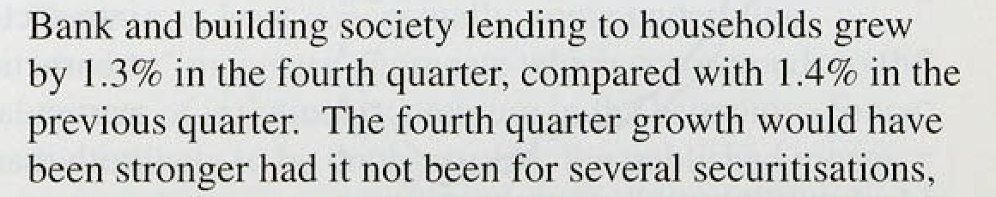

1'J

*Monetary*

the first half of 1993. This pattern is consistent with the recent.slight upturn in the housing market.

All these factors together suggest that individuals’ borrowing for consumption was relatively strong in the final quarter of 1993. Earlier in the year, individuals were financing their extra spending by saving less rather than borrowing more. The fourth-quarter growth in *both* borrowing and deposits by the personal sector suggests that extra spending has been becoming more broadly based.

Unincorporated businesses reduced their stock of bank and building society borrowing by £0.1 billion in the fourth quarter, after an increase of £0.4 billion in the previous quarter. The pattern during the year suggests that their financial restructuring in the early pari of the upturn is almost over—in which case, more of their

.future income will be available for spending in 1994, rather than being used to repay their existing debts.

The public sector made a large contribution to M4 growth in 1993. Banks and building societies switched into gilts following the change in the government’s funding policy to include these institutions’ gilts purchases last year. But the shift is also likely to have reflected the *cyolical* component of the PSBR. This is expected to diminish—and the M4 private sector’s demand for borrowing to pick up correspondingly—as the economy recovers. The medium-term correspondence between M4 and lending by banks and building societies would then be re-established.

The Divisia measure of money uses a different method of disaggregating the broad money data. It weights the various components of M4 according to their transactions characteristics: the higher their transactions component, the. more likely it is that these deposits will be used to finance expenditure. In the fourth quarter, the annual growth rate of the Bank’s Divisia index increased for the: fourth consecutive time, to 4.7&• compared with the trough of 2.6% in the fourth quarter of 1992.

Growth came from.both the personal and corporate sectors„with corporate,.growth,at its fastest since 1991 Q1.



’Ofñeiâl intosf.rates:were cut by 50. ñasis points on 23.November. Altiiough slightly ahead ofthe'Budget, the.reilucnon took:account of.tire i:mplications .of the

.. i i 

fiscal tightening announced in the Budget for demand and activity and thus for inflationary pressures (see Section 3 for an analysis of the Budget measures). With the Budget tighter than the markets had expected and the inflation picture continuing to improve, market interest rates fell following the Budget. This reflected a growing view that rates would be cut again in the first quarter of this year, though the speculation later receded.

L k. .incl trntJt-» cixhttd x ‹›rld interest ratr i icIcI

**UK trade-weighted interest rate differentials**

hur

On 2 February. three and twelve-month money-market rates were 5.449a and 5.25%, compared with 5.40'fc and 5.289a before the Budget and a low of 5.22% and 5.02% in December. The structure of sterling futures rates on the same day suggested that the markets still expect a further '/. point cut in interest rates, but not until the second quarter. Beyond that, implied forward rates suggest that official interest rates are expected to rise gradually, reaching a peak at around 2002. However, the level of this implied interest rate path has fallen substantially since the last *Report,* reflecting lower expectations of future inflation (see Chart 2.4).

The UK trade-weighted world interest rate differential increased slightly between September and January, with weighted world interest rates falling by more than those in the United Kingdom. But this differential remains small, at no more than 40 basis points up to a one-year maturity (Chart 2.5). Sterling’s effective exchange rate stayed within a narrow range but has strengthened a little since the last *Repurt* (Chart 2.6).

**2.3 Summar**

Narrow money, M0. has continued to grow erratically, at an annual rate above its 0&oW% monitoring range.

Broad money growth increased to an annual rate of 5.4% in December, within its monitoring range. Much of the recent strength in M0 can be explained by earlier interest rate movements, and M4 lending has been weaker than M4 itself. The increase in M4 growth reflects the rise in real money balances, especially of the corporate sector. These data are consistent with a continued recovery and further balance sheet adjustment by indebted firms.

Official interest rates were reduced by 50 basis points on 23 November. and market rates have also fallen as inflation expectations have come down. The very small UK trade-weighted world interest rate differential implies that little change in exchange rates is expected.

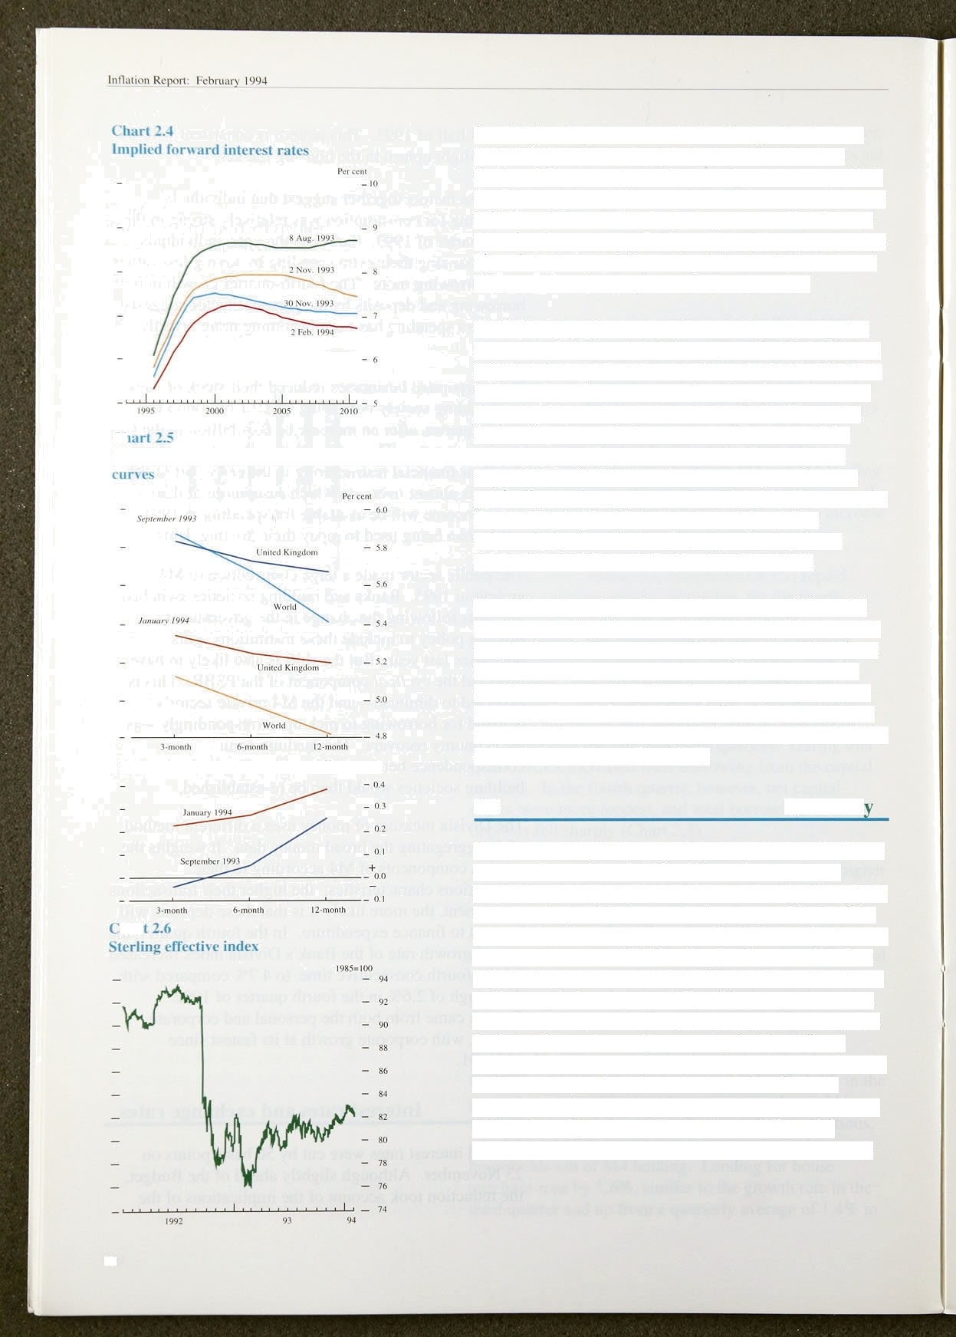

16



In the shori run, inflation is affected by movements in demand relative to productive potential, and the interactions between the two.

**Table 3.A**

**Expenditure components of GDP at constant**



Quarterly.changes Four-gunner

heailges

Consumers’ expenditure 0.5 1.0 2.0 2.6

Public consumption 0.9 -0.1 -!• ! 0.8



Doñics‹ic:demand 0.8 .0.3 I.'6 J.4

Exports --:f.4 2'.9..: 1.5 S.2



Imports -O.O.. I .3. 0.4 I.b,

UDP 0.7 0:7 I .9 2.2

*Overview’*



Demand

GDP increased by 0.7% in the fourth quarter of 1993, to a level 2.5% higher than a year earlier. For non-oil **GDP,** the respective figures were 0.59c and 2.19r. The data on the expenditure components of **GDP** for the fourth quarter are not yet available. In the year to the third quarter, the main contributions to growth came from consumer spending and net trade (see Table 3.A).

The impact of indebtedness on consumption and investment seems to be receding. The saving ratio has fallen further and companies moved into financial surplus in 1993.

**Chart 3.1**

**Personal sector saving and borrowing**



*Personal syendiiig*

Consumers’ expenditure rose by 1.0% in real terms during the third quarter of 1993, the sixth consecutive quarterly increase. The saving ratio declined to 10.69c, from 11.7% in the Second quarter and 12.8&o in the first (Chart 3.1). The fall in the saving ratio more than

° accounted for the I.59c .rise in consumption between the

. first and third quarters as real personal disposable income declined by IN. Not since 1969 has falling disposable income been accompanied by rising consumption in consecutive quarters. There was a similar fall in the saving ratio after the recession of the early 1980s; but that fall was aided by tax cuts and fuel1ed by extra borrowing following financial liberalisation,.a process which is now largely complete. By contrast, the tax increases announced in the March and November Budgets are expected to reduce real disposable income growth buy t'/i percentage points in '199.4/9?, .one percentage point in. 1995/96, and a further

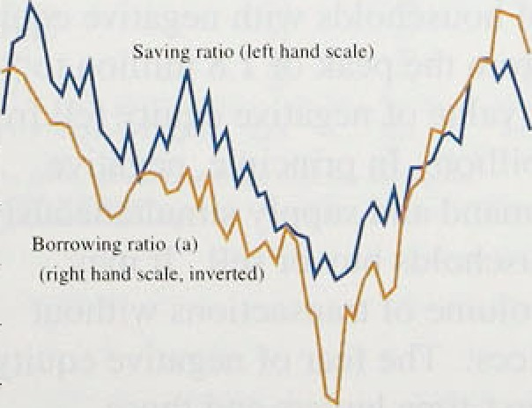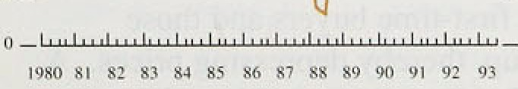

'

— '°

###### .half a percentage pofnt ih 199fi/97.





showed that in December a balance of 34% of retailers had higher sales than a year ago—back in line with the balances reported last summer.

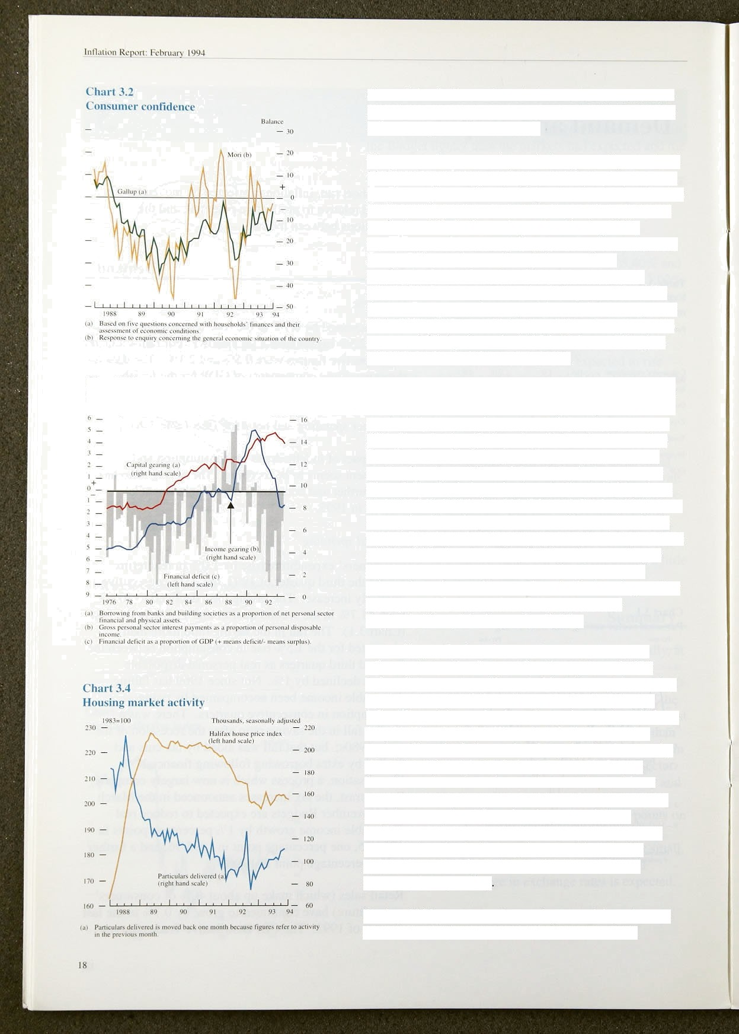

L'liart .S..3

f’tr nnnl stctnr geitring and fi»a»ciaI 4eficit

The personal sector saving ratio has generally remained higher during this recovery than in previous upturns, as people sought to offset the higher levels of debt. For the next two years or so, consumption growth will depend on further falls in the saving ratio. During 1993, consumer confidence may have benefited from the falls in unemployment, even though income from employment was flat (Chart 3.2). If real personal disposable income were to stay at its present level for the next two years, then a growth rate of 2'/i% a year in real consumption would imply a fall in the saving ratio to around 6% by the end of 1995. This would be just above its value in its trough in 1988.

One reason consumers built up their savings during the recession was the impact of falling asset prices. particularly house prices, on real debt burdens. These falls also raised capital gearing (defined as borrowlng from banks and building societies as a proportion of personal sector net financial and physical assets: see Chart 3.3). Capital gearing has declined slightly, from an estimated l4.9% in 1992 Q3 to 13.9% in 1993 Q3, as asset prices have begun to recover. House prices have risen 1.7% since the February trough (Chart 3.4), but are still I 1.5% below their May 1989 peak, according to Halifax Building Society data. Despite the rise in prices, the volume of transactions in the housing market (as measured by particulars delivered to Land Registries) has picked up only slightly.

According to Bank estimates, the 3% rise in house prices between the first and fourth quarters of 1993 reduced the number of households with negative equity by almost one third, from the peak of 1.8 million to

1.3 million. The total value of negative equity fell from

£11.7 billion to fi7.7 billion. In principle, negative equity affects both demand and supply simultaneously, since few affected households buy or sell. It may therefore reduce the volume of transactions without much net effect on prices. The fear of negative equity may, however, deter first-time buyers and those considering trading up, thereby depressing prices. A small further rise in house prices would markedly reduce the scale of negative equity, and stimulate consumption spending

**During** 1993, consumer borrowing net of deposits was

£1.5 billion higher (at £5-6 billion) than in 1992.



**Table 3.B**

**Factors limiting manufacturing capital expenditure (CBI Industrial Trends Survey')**

Pt'rcenuigc of firms:answering yes

Inadequate Ldcs:’oF Lark of Cast of Uñcenain‹y



fiâencc finance demand _



1993 Q3(6j 44 27 



1993 Q4 49 2fi 3 4 53







**.Table 3.C**

**Reasons for manufacturing** capital **expenditure**

**(CBI Industrial** Trends Survey•)







*993.QO(#i 22’ 67



.:i%3 Q4 26. 72. S0e



Personal sector income gearing, which had declined sharply with the falls in interest rates since 1990, is

.estimated to have risen slightly in the third quarter. Meanwhile, the personal .sector was a net purchaser of company securities in the first three quarters of 1993, and flows into life assurance companies and pension funds continued at a steady pace. The strength of the stock market—the FT-SE 100 index rose 7.39r between the third and fourth quarters, and was 18.3% higher in 1993 Q4 than a year earlier—has substantially increased

personal sector wealth.

*Investment and stockbuilding*

So far in this recovery, companies have been slow to increase investment, partly because of the large debts they took on in the late l980s. In 1993 Q3,

non-residential rixed investment was 0.4% higher than in

the same quarter of 1992. However, this followed a year-on-year fall of 29c in Q2. The January CBI Industrial Trends Survey reports a balance of 7&r of manufacturing firms expecting to increase investment in the coining year—the first positive balance since July 1989.

Investment remained.higher during the recent recession than in previous downturns. Total investment by industrial and commercial companies (ICCs) averaged 8.0% of **GDP** in 1992, compared with 6.5 in 1981 and 6.4& in 1975. Higher investment has reflected higher profitability, with a real rate of return on capital (excluding North Sea oil companies) of 7% in 1992, compared with 3&o in 1981.

Table 3.B shows the reasons currently given by firms as limiting investment. As in the. previous cycle, uncertainty about demand was the major factor until this quarter. At the same time, however, the CBI’s January quarterly survey (Tabte 3.C) shows that, in 1994 Ql,

.25% 1of firms are planning to invest to expand capacity. This compares with.22% in 1993 Q3, and only 11to in 1982 Q4,.a similar stage in the last cycle. It seems that firms are becoming more confident about the strength of future demand:and that investment may.pick up in the

.coming.months: Moreover, other business surveys since.

###### the Budget show increasing confidetice: the Purchasing

.Managers’ Index rose to 54.6 in December from 53.6 in

###### .i3ctobñr, and the Institute of Directors Survey showed

°. tiu»inasseotifidense improving to a balance of 47% in 'Dwefiiber, from.42a ifi October.



lRoinR x Fbmagé94

C’hart fi.o

lC’C’s’ financial balance



0



t’hart .3.I›

Changes lfl StOCkS (3-f1n0$th muving average)

Inrrczse/time n•a in si•tks. t hillinns

— — ‹

4 ho e tcon»ni siuck«.



Chart 3.7

Relative domestir demand and the UK trqde balance

P =nlagcofmo y€DP l99O=1QQ

106



ICCs have continued to make!net repayments to banks: a total of £6 billion last year,. in..sharp.contrast.to tlieir average *borrowing* of £23.9 billion a year between 1988 and 1950. This is partly because they have turned increasingly to the capital markets for finance; their net capital issues totalled £14.9 billion in 1993, compared with f8.3 billion in 1992. In addition, retained .earnings

rose strongly this year, enabling firms to finance more of their investment internally. ICCs’ retained earnings were £24.6 billion in the first half of 1993, up about 35&o on a .year earlier. Since they have .grown much

faster than investment spending, the corporate sector has moved into .a financial surplus, of fi2.3 billion, in the first three quarters of 1993 following fvve years of large deficits (Chart 3.5).

Stocks in the manufacturing, wholesaling and retail sectors combined have shrunk in 14 out of the 16 quarters since 1989 Q3 (Chart 3.6). In the previous recession, stocks decreased for only seven successive quarters. In contrast to the 1980—8,1 recession„ when the

.manufacturing stock-output ratio increased as GDP fell, the recent downturn saw it .fall steadily, as improvements in stock control outweighed any cyclical effect. For.the economy as a whole, it is expected to continue falling.

In manufacturing, however, according to the CBI Industrial Trends Survey, more firms are pla!nning to increase stocks in the present recovery than in previous recoveries.

*Over.seas trcide*

The visible trade deficit in the first three lquarters of

1993 was £8.8 million, down from £9.1 billion during the: same period of 1992. Tire fall was eniirely, the result .of trade with EU countries; .the!deficit.with .the.rest .of the world.increased from £6.6 billion to £7.7 billion.

The importance of relative demañd!move.ments for the balance of trade is illustrated i:n.Chart 3:.17. .Between 1985 and 1988, UE domestic demand,increased ñy



it

 



arourid eight

###### - •' investment.thai saving:rates. .

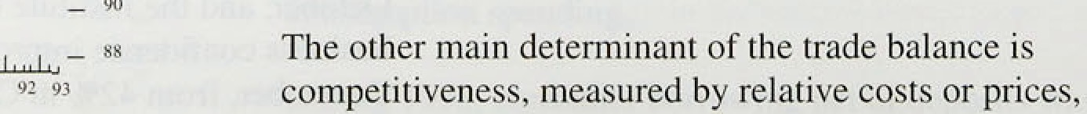

Table 3.D

UX trade **volumes in nun-oil** goods (excluding

ratics)

1992 Q3 1993 Q3

10.3

spare capacity, improved competitiveness should lead to greater capacity utilisation, by increasing the rewards for selling abroad. However, these supply-side effects take time to emerge, whereas the effects of shifts in relative demand come through more quickly. Since sterling’s

departure from the ERM, UK relative unit wage costs

have fallen by around 149c. As a result, although UK domestic demand has grown by around two percentage points more than demand abroad, growth in export volumes has exceeded growth in import volumes, contributing around 0.8 percentage points to the 2.2% growth in GDP in the year to 1993 Q3.

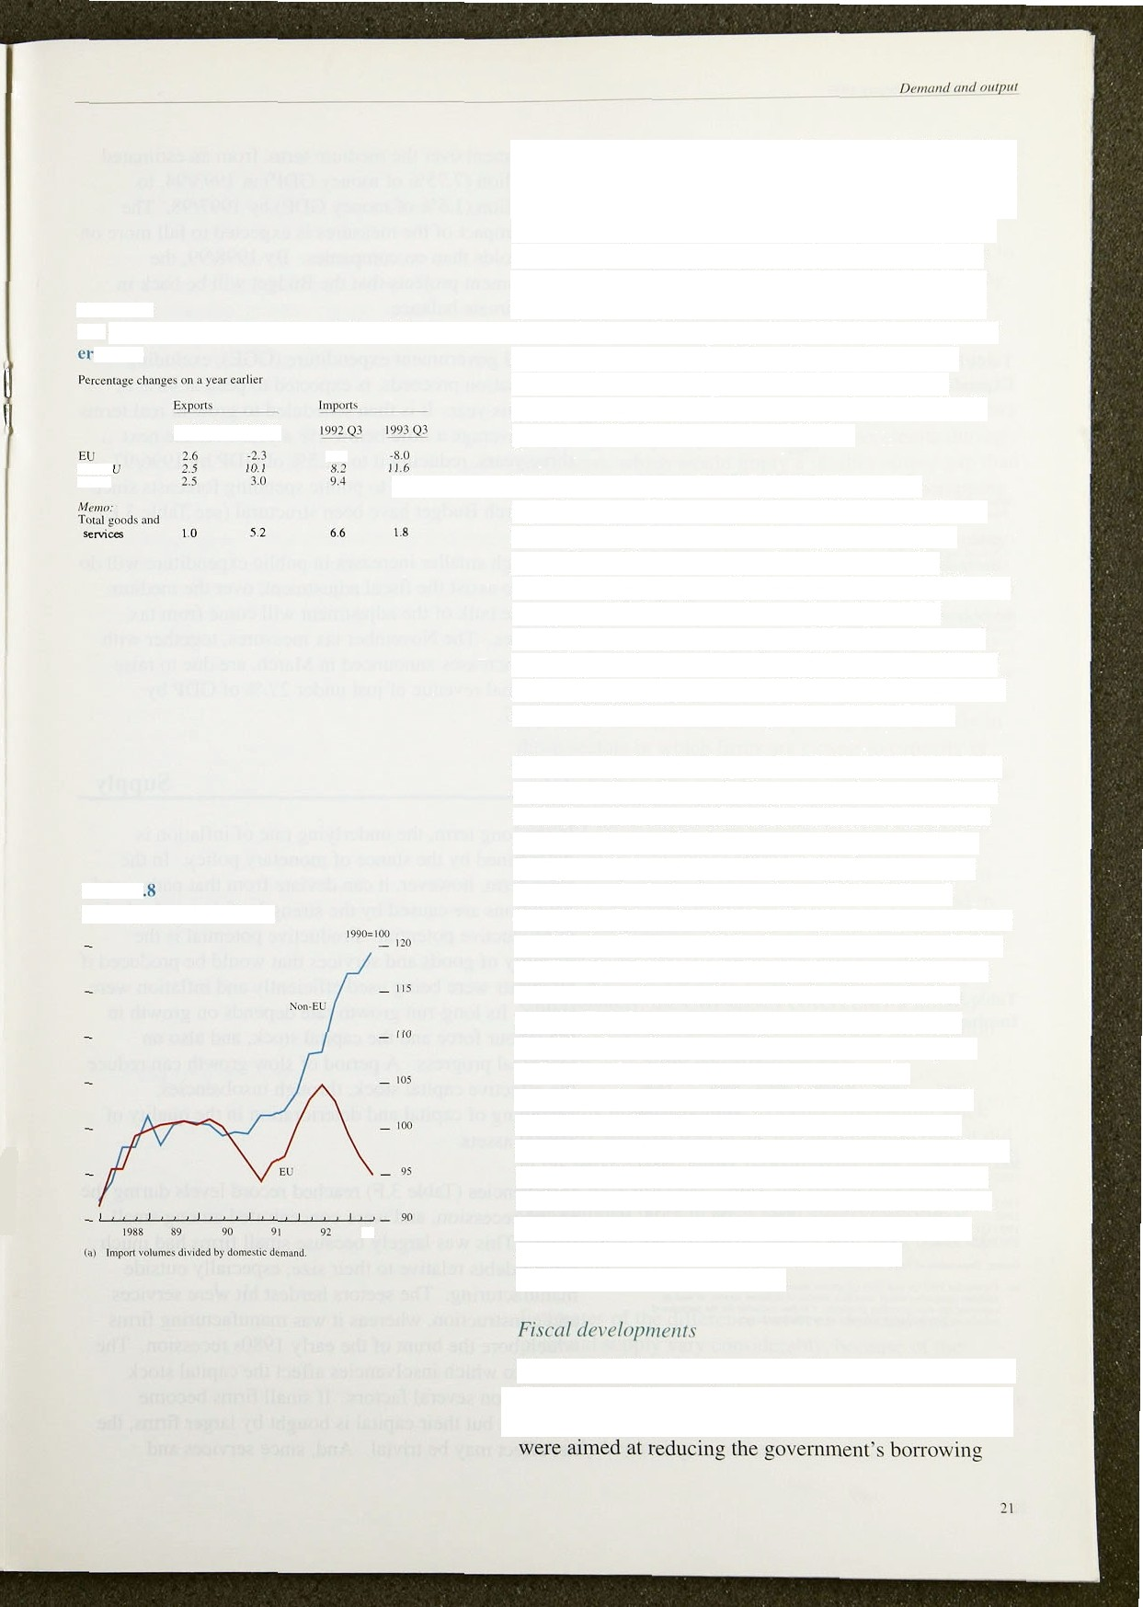World

**Cbart 3.**

**UK import** penetration*

0.6

93

Just as the composition of domestic demand is significant, so is the composition of the trade balance. For a given level of imports, for example, a higher proportion of investment goods will increase the economy’s productive capacity in the future. Within the category of finished manufactured goods (which accounted for half of imports in 1992), the volume of capital goods imported rose by 7.8% between 1992 Q3 and 1993 Q3, compared with a fall of 3.89r for cars and a rise of I.8% for consumer goods excluding cars.

Closer analysis of trading performance is unfortunately compheated by the continuing uncertainties associated with the collection of EU trade statistics. It is notable that the volume of both imports and exports with the European Union has been lower than expected, with imports particularly depressed (see Table 3.D and

Chart 3.8). By contrast, UK exports to and imports from outside the European Union have risen strongly. If, for the European Union, both import volumes and export volumes have been underrecorded and to a similar extent, then the net contribution of trade to growth should be broadly correct. However, as export price deflators are used in calculating estimates of manufacturing output, it is possible that the level of output as a whole could be understated. There are several ways to gauge the size of such an effect. One is to use export price equations to estimate the extent to which recent behaviour differs from what would have been expected based on historical experience. This suggests that manufacturing output is being underestimated by around 1%.

The first Unified Budget, on 30 November, included the Govmnment’s plans for taxation as well as spending (to 1996/97). The combined tax and spending measures



”I”ahl .J.K









I .ABR





requirement over the me‹iiam term, from an'estimated

£5,0 billion (7.75% of money GDP) in 1993/94, to

£12 billion ( I.5% of money **GDP)** by 1997/98. The direct impact of the measures is expected to fall more on households tlian on .companies. By 1998/99, the.

Government projects that the BUdget will be .back in approximate balance.

General government .expenditure **(GGE),** excluding. privatisation proceeds, is expected to peak at 45% of GDP this year. It is then schedulecl,to grow in real terms by on average a little below I %: a year over the next three years, reducing it to 42.59r of **GDP** by 1996/97.

Some of the changes to public spen‹iing forecasts since the March Budget have been structural (see Table 3.E).

Com:it box crniuciu debt inicrc st



—



ti cue ra l govern ment ex pt nditure - 1. I -fi.7



r»si‹ 3.r

l nsolvencies by sector



T‹›1al Od er' Msnut'a«- Conslruu- Roto I- F nans nscJvcn- luring. tion iiiy and ciaJ and cies whoJesatii›jz business

services

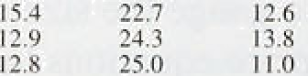1980 I›.890' 713 33.9

I98 I 8;S96 9 i 8 34.9

I942 12,067 990 36.6

Although smaller increases in public expenditure will do much to assist the fiscal adjustment, over the medium term the bulk of thel adjustment will come from tax increases. The N,ovember tax measures, together with those increases announce‹i in March, are due to raise additional revenue of just un‹ier .2'/2fiO of GDP by 1996/97.

## 2 Su 1

In the long term, the underlying rate .of inflation is determined by the stance of monetary policy. In the short term, however, .it can deviate from that path—añd deviations are caused by the strength of demand.relative to productive potential. Productive potential istthe quantity of goods an‹i services that would be produced if all inputs were being used efficiently and inflation were' stable. Its long-run growth ritte depends on.growth in the .labour force and the capital stock, and!a1so, on technical pro'gress. A period .of slow growth.can reclu.ee the:effectiv,ee: capiital. stock; insolvencies, scrapping.of:ca



assets.,



20.2 20.3 I 6.7



. 20.4 19.8 I 7;i8



###### Insolvencies

ent.rated amen

rig the,

Source: tkynmcni oF Trade *nd' fnd usiry .





firms. This. was largely’because small firms mad.much bigger debts relative .to iheiF site, espeeialJy outside



and construction, **:wheieas** i:I.was';nanu:factiiring firms



extetit to:whieh. insolvencies affect the: capital stock: depends. on several .factors.’ .If.small.firms .become insolvent.but.their capital is bought,by! larger **fi:rms,.** the nét.effect.may be trivial. And, since services and







construction were hardest hit, and are two of the least capital-intensive sectors, the capital stock may have been less affected than in the previous recession. Also, the composition of the unused capital is relevant: it would be easier to re-use buildings, for example, than to re-use a machine designed for a specific manufacturing

process.

The **CSO** measures the capital stock using a perpetual inventory method. This assumes that assets have fixed lives, regardless of economic conditions. Yet the scrapping of capital goods is likely to accelerate during recessions, which would imply a smaller output gap than would otherwise be the case. Information on scrapping is hard to come by and tends to be anecdotal. But various studies suggest.there was less scrapping during the last .recession than in the early 1980s. Indeed, with investment being higher than in previous recessions, it is possible that it remained above the basic level needed to cover replacement, implying that the capital stock may not have fallen.

lt is likely that investment will pick up more quickly in those sectors in which firms are closest to capacity or more confident that they will soon reach that stage. The number of manufacturing firms operating below capacity fell from 60% in October to 579a in January, according to CBI survey figures. The p=reatest improvements were in food, drink and tobacco (down from 37% to 33&o), in chemicals (50% to 419o) and in mechanical engineering (649c to 58%). The percentage of firms in the motor vehicle and transport industry reporting below-capacity usage remains high, at 92%.

Unfortunately, the **CBI** survey covers only a limited

.number of sectors. and there is no similar information about the rest of the economy.

Summing up the available evidence, the capital stock probably suffered less in the recent recession than it did in the early 1980s, partly reflecting the fact that different sectors were affected. Since the recent recession was concentrated more in areas such as services and construction, the effects on supply will have been less iignififiant.

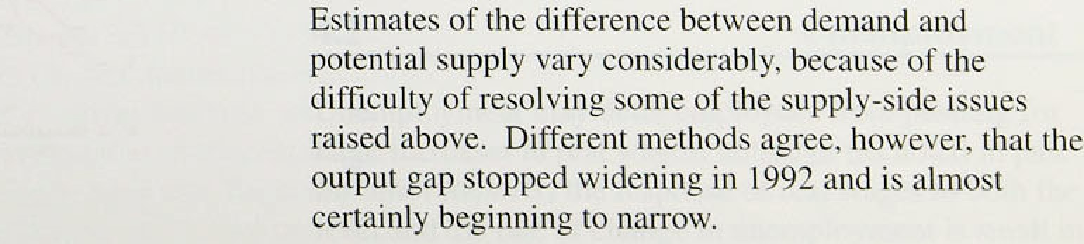

Int1uttcn kcjx›rt: Fehruar¿ 1994

## 3 3 S

Non-oil **GDP** increased by 2.19 over the year to the fourth quarter, with the main increases in aggregate demand coming from consumer spending and net trade. Further increases in personal consumption are likely, but will depend on the .saving ratio falling, because real personal disposable income is unlikely to increase much over the next two years. The fiscal adjustment embodied in the Match and November Budgets will fall mainly on the personal sector, but higher levels of.household

wealth will reduce the incentive to save. Investment and stockbuilding are likely to contribute more to growth as the recovery continues.

It is very difficult to measure potential supply, partly because the degree of scrapping in the last recession is uncertain. The capital stock probably suffered.less than in the early 1980s. But the output gap is likely to narrow

.as demand increases.





**Tnble 4.A**



United-Kingdom,’aens‹<•//y *edjM•red*

**Unirs** Latest HaIF year Yeer agn.



l09.8.

Average earnings are rising more slowly than they have

,done for a.generation. But real wages per employee (money wages deflated by the TPI) have grown by 4.2% over the past two years. Table 4.A summarises the latest labour market indicators. In many firms, nominal wages reflect a bargain between employees and employers over

planned increases in real wages. How the real wage bargain translates into nominal wage increases depends

6 Dec. 93 9.8 10.4

10.b

on bargainers’ expectations of inflation. If, for instance,

Change tqoq)(by 000.'s Surorner 93 t6:0 94.0 109.0









0,j9’ 0’.2d ”0.71

Ulideztying; whale





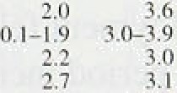



yqtia iiuinsi ’élliiniiag.iniimployyneru•relntcd.bin i.



::i0



price increases brought about by tax changes are interpreted as signalling persistently higher inflation, wage bargains will be higher. This will lead to more unemployment than otherwise, and higher nominal wages and prices.

1. No i and rea earn n s

The twelve-month increase in underlying earnings has fallen from 3'logo in August to 3% in September, October and November. Earnings growth fell in all **STCtOlS** . The IRS median measure of settlements in the whole economy has flattened out at 29c. Within the total, public sector settlements have continued at 1.5% (Chart 4.2). In the three months to November, manufacturing settlements averaged 2.2%, compared with 2.3 in the previous three months. The CBI also reports that settlements in services declined, firom 2.69c to 2.4to, between the third and fourth quarters. Despite .the improved financial position of many companies, the CBI says that about one fifth of manufacturing and one tenth of service companies are freezing pay.



‘The.increases in pre-tax real wages reported recently are consistent with behaviour in the labour market during the!:1970s and .1980s. However, i.ncreases in nomi.nal earnings are‘over 4!Jt percentage poi.nts lower than

. ;during.the 1980s, almost all. of which.can be explained by.lower price.inflation.



 looo,meennt



e

Unempl:iy:mentsmay deter employees:.from pushing for



.large increaseskin real wages, although ( noted.in..past

friction *Sep’orts)* the:response.of real wages‘to both the

.level ând the..ra.te of chan:ge:in:..unemployment is smal.l..in.

the United Kingdom. Since the number registered began to decline in February 1993, the total fall in employment has amounted to 226,100. Historically, the claimant count (which includes only those claiming unemployment-related benefits) has varied much more than the Labour Force Survey (LFS) measure (which includes all those over 16 who are out of work and actively seeking it)—see Chart 4.3. The claiiTlant count of unemployment fell by 17,200 per month on average last year, compared with 27,600 per month in the year rrom July 1986, the last downturn. even though output is growing at less than half the rate it was then. Chart 4.4 shows the unemployment rate based on the claimant count, and the short-term unemployment rate.

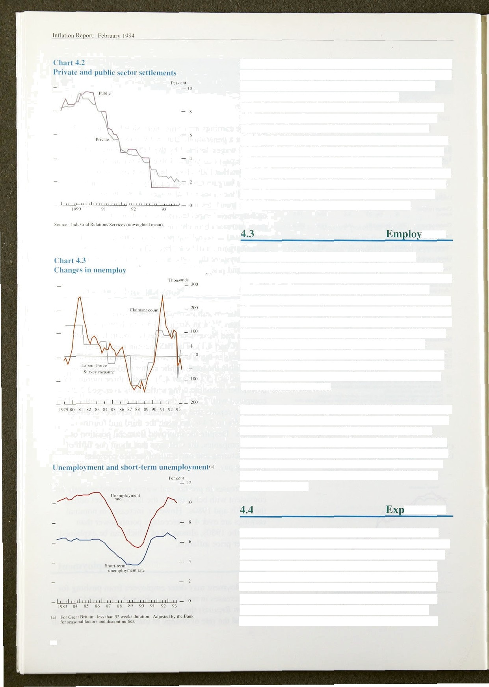

ment

According to the Department of Employment’s employer-based figures, the workforce in employment rose by 91,000 in the third quarter of last year. But there are growing differences between this series (which counts the number ofjobs) and the Labour Force Survey figures (which count the number of people in work), and the differences are hard to explain. Comparing the latest Survey (for summer 1993) and the winter 1992 Survey, total employment increased by 135.000, although

full-time employment fell. The employer-based figure over the same period increased by 54.000. Total hours worked in the economy actually fell between summer 1992 and summer 1993.

Other, more timely (but less precise) indicators of labour demand also offer conflicting evidence. The number of unfilled vacancies at Job Centres rose to 145,000 in December 1993, the highest figure since October 1990; on the other hand, in manufacturing industries there has been a substantial rise in hours iost through short-time working since August 1993, and a comparable fall in overtime working.

**ectations**

The real value of a nominal wage increase during the period between settlements depends on what happens to prices. So, in making agreements, bargainers will take account of both (i) the unexpected inflation since the prevIous settlement, and (ii) the inflation they expect before the neKt settlement. Chart 4.5 shows how the mean expectations of employees surveyed by **Gallup** have changed over time. **Since** 1991, inflation has turned out lower than employees had expected. As a

26

'Chart 45

Actuat inoation vs employees’ expectations,

— Acioal 

_ 2





Table 4.B

Unit wage costs and their components

Ptrrccntngc changes on e period in puviuus yenr

Ouiput Em'ploymeni Lubour Earnings per Unit wage



result, recent nominal wage settlements have resulted in hi:gher than expected real wage increases, which may help to hold down future wage settlements, provided expectations of inflation adjust rapidly. Inflation expectations remain above 4% per year, nominal wage demands are likely to put upward pressure on costs and

unemployment.

4 Pro f

The benefits of productivity improvements may not be divided evenly between those in and those out of work, because they tend to be split between reductions in the price level (which increase everyone’s purchasing power), increases in take-home pay (which benefit only those .in work), and increases in the profit share.

Productivity growth has slowed recently (see Table 4.B). The level of labour productivity barely rose in 1993 Q3. In manufacturing, the slowdown was even more marked, from a twelve-month rise of 6.1% in July to 3.1la in October, and no increase over the latest three months.

Since earnings growth has remained fairly steady, unit

|  |  |  |  |  |  |
| --- | --- | --- | --- | --- | --- |
| ta) | Whole.economy | wage costs in the whole economy have begun to rise | | | |
| I'99I | -2:3 | -2:8 | 0.5 | 7:5 | 7.0 again (see Chart 4.6). |
| l9g2 | -0:5 | -2.7 | 2.3 | 6.8 | 4.4 |
| t992 | Q3 -0.I | -2.7 | 2.7 | 8:9 | 3.2 |
|  | Q4 0.2 | -3.0 | 3.3 | 6.2 | 2.9 .In the medium term, this should not be a cause for |

(b) Manofscturlñg induxwy

|  |  |  |  |  |  |
| --- | --- | --- | --- | --- | --- |
| Q2 | 1.7 | -2.4 | 4.4 |  | |
| Q3 | 1.9. | -0.8 | 2.9 | 4.0 | 1.1 |



i992. Q3 0:2 -4.’7

Q4 0A -5:6





4.8 6.6 I.€

5.0 6. i I.3

6.2 SP’ -0:’

7,d 4.‘7 -2.7

†.0. 4:9 -I.9

5.0 4:4 -0.6



concern. .If firms now find it less costly to vary the number of staff they employ in line with changes in the demand for their products, then output and employment fluctuations should coincide more closely than before. This appears to be happening, as noted in the last *Inflation Report.* The corollary is that productivity should fall less in a recession and rise less in the recovery; productivity growth should stay closer to its long-run trend.



Whole economy productivity end unit wage costs









## 4 6 S

The .labour market has changed considerably in the last decade. Wage bargaining is more decentralised; far fewer employees have their wages set by collective bargaining; and companies make more flexible use of their workers. But wages are still strikingly unresponsive.to changes in unemployment. Either the labour-market reforms have yet to bear fniit, .or other forces of inertia are at work to offset them. The most iinportant fact‹ir preserving the bargaining power of employees may:be the scarcity of their skills and an unwillin ness.to recruit from the ranks of the unemployed. if this lis the case, then those in work, w1iether‘members of unions.or not, will stilt be able to

27

llif1aiir›n kepori: February 1904

push for.real wage increases that, in aggregate, keep others out of work.

The question that matters for the medium-term inflation outlook is what is the level of unemployment that is consistent with low and stable inflation. As noted in previous *Reports,* .estimates of this non-accelerating inflation rate of unemployment (NAIRU) vary from around one million to a figure not much below the current level of 2.8 million, Given the state of employees’ inflation expectations (see above), it is very unlikely that wage settlements would be as low as they now are unless the NAIRU were substantially below the current level of unemployment. How much below will become clearer only as unemployment declines. As yet, there has been little sign of upward pressure on nominal earnings growth.



**Table 5.A**

**varlebility of fsctor prices, profits and** retail



’Average Product- Unit Input Profited RT'TX



**CO'St4**

1973.Q3-

1978 Q3 2.I 2.4 z.7 . 3.8 I 1.8 I.9

1983'Q3 I.:6 2.\ 2.6 2:.5 1\›.3 I.6



l98b Q3—

1993 Q3 0.9.. 0.9 I.3 l -9 4.7 !•8

'¥¥hole peziod . 1.7 1.8 2d. 3.I B,Y !-8





Firms' pricing decisions are influenced by two sets of factors supply and demand conditions. The

supply-side factors include the cost of inputs, and the technology used to combine these inputs to produce output. These determine how firms’ costs change as output changes. But it is vital to distinguish between changes in factor costs which are one-off, and will therefore affect inflation and expectations only in the short run, and those that are likely to be part of a continuing process. Table 5.A shows how variable these

‹different cost elements have been in the past. The rate of change of input prices and productivity has been much less stable than increases in average earnings. Over short periods, movements in the rate of change of input prices give less information about changes in underlying inflation than do similar movements in earnings increases.

In the shori run, firms’ costs will not vary strictly in proportion to output. When output is below the capaclty of existing plant and employed labour, extra production may at the margin cost relatively little. In these circumstances, firms may be willing to cut prices to stimulate demand and, by increasing total revenue, to make a larger contribution to fixed costs. But when capacity is being fully used, the marginal cost of extra

.output may rise rapidly, leading to sharp changes in pricing behaviour. This is particularly likely when some factors of production (eg plant and skilled labour) are in inelastic supply in the short run.

however, a firm’s optimum price will also depend on hfiw responsive (elastic) demand is to changes in prices. This elasticity may change with the .level of demand: in a boom, for instance, consumer demand may be less sensitive to changes in relative prices than it is in a recession. But elasticity may also change independently o( the cycle. One example is where new entrants to a market increase the elasticity of demand faced by existing firms (eg in food retailing in the United Kingdom at.present), encouraging changes in pricing

.policy. The recent emergence of low inflation may itself **ha caused an increase in** the elasticity of demand **for indivtduai Rrms’ products,** because low inflation helps

.pt chasers tn distinguish between relative price changes

29

Inf\.nion Rcyurl: February 1fig4

Chart *.l

The exchttnge rare. UK import prices and major six producer prices







— 16





Chart 5.2

Sterling oil **and non-oil commodity prices**

and

And information on the prices charged.by ,different frrms has a longer ‘shelf life’„ as prices chafige less, frequently. This ensures a greater pay-otf to gathering information on prices from several sources,.so consumers will spend more time searching for low prices, and the elasticity of demand faced by firms will increase. This is



particularly true of big purchases, such.as durables, or regular purchases, such.as basic food.

UI 0 t

Overseas imation will affect UK inflation only to the extent that it feeds through to the prices of tradable goods. That depends on how far the exchange rate moves to offset the difference between inflation in the United Kingdom and abroad. In the short term, import prices can affect UK inflation in two main ways. .First, higher import prices increase the costs of UK firms, since imports account for around 35% of manufacturers’ costs. Second, imports of consumer goods have a direct impact on RPIX, by increasing the supply costs of retailers. (In 1992, imports of finished manufactured consumer goods were equivalent to 18% of the value of total imports of goods and 69 of consumers’ expenditure.) How much of the increased costs of manufacturers and retailers is passed onoto purchasers depends on the level and elasticity of demand.

Past movements .in sterling import prices have reflected changes in exchange rates more closely than changes in foreign prices (see Chart 5.1). To the extent that UK imports are purchased in competitive world markets, and because the United Kingdom provides only a small

q fraction of total world demand, UK import prices would be expected to change one-for-one with any change in

'" the exchange rate. In fact, between 1992 Q3 and

p 1993 Q3, import prices rose by around 9'/i8b„ virtually  matching the fall in sterling’s effective exchange rate.

— — i20

Oil,(al

UK-ucighiod indes:



Commodity prices.now have less effect,on UK inflation than they!did in the 1970s and 19.80s. ,ln .1.973, non-oil commoditiés represente‹J l7& of UK importi; in 1990, the figure was nearer 9&o. ,Nevertheless, eo.mmodity prices.are particularly: volatile,. so.they.Can. affect.UK

.inflation..in.the.siiort.tqrrir.and,can p;pyide.a,timely,

indicator. of deriiand/supply’i!mbaiances'abroad. The

.styr1ing:index o UK-Weighted.non-.oil commodity

pricei.rose:by 79b: ia 1993 Q4.(see Chart 5. ). lne1uA!ng

###### .oil, whose price has fallen, commodity prices rose by lesslthan‘ 1&. Over 1993 as a whob, bath the non-oil



Ghart 5.3

**ICCs’ return on capital** • **and capacity utilise 0° in the manufacturing sector°›**

and all-items indices fell, with decreases in industrial commodity prices outweighing higher food prices.

Much of the latter were the result of short-term supply

factors whfch are unlikely to persist during 1994. Since GDP growth in the seven largest industrialised countries is likely to be sluggish in 1994, non-oil commodity demand and prices are expected to remain relatively

depressed.





lB72 74 36, ’7# T# ’82 84’ 96 88 C1 ’.92 94

Crude oil prices, measured by close-dated Brent crude.

, fell by over $4 per barrel in the fourth quarter of 1993 to stand 30&r lower than in 1993 Q1. The fall reflected

* several factors: lower demand .forecasts; increasing non-OPEC production (especially in the North Sea); the potential additional supply from Iraq; and OPEC being unable to cut production to boost prices. These developments make it unlikely that oil prices will rise

, significantly in 1994.

5 2 P bi it a ns nd a k s

**.Chart 5.4**

***Pr*ofitability1•1 in the last three recessionsfrecoveries**

_ ..’Si’.f’’0n’:1990’.QA’.



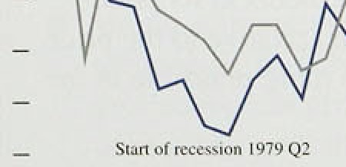

Firms’ profitability and their prices in relation to costs are closely related and have implications for inflation and output. Profitability is best measured by the return producers earn on the capital they employ. That depends on (a) capacity utilisation and (b) how output prices move relative to factor prices. The two are interdependent. Capacity utilisation rates have a strong link to profitability (Chart 5.3).

As the economy recovers, an increase in capacity utilisation affects profitability in three main ways:

###### .(i) it reduces fixed costs per unit of output, giving a

— • higher return to capital. Recovery may also allow

_ , firms that have been hoarding labour to use it more

###### , effectively, thereby increasing average output per

.head and reducing average unit labour costs. This may, lead to an increase in the ratio of prices to average costs;

_ , (ii) it may produce higher marginal cost3 relative to average costs; and therefore higher prices relative to

' : average.costs:; .and

— :. ”

###### s on factor prices.



In.combination, these:factors explai:n. why profi:tabfli.ty,



###### :arera:ge‘.margiiis‹and iriflation (rqlative.to.the long-run rate deterrtiinidby›monetary policy) are.al11lke1y: to increase in a recovery:.





**Margins:and ma!rk-.ups**

**lntrt›J ucti‹›n**

The.terms '.m‹irg:ins t and 'in‹irk-ups' Are soften. used syiuinyrnously, although in fact they:are quite dilt"erCl1t: It.1s.WPI th ctai itying what lhey mean in this ñPJirir/. 'Aveixige in‹u-giti* reters t‹› the

absolute diltereiice between a: g•ood's set.1.in r ' ce and the averiigR Vi)Fi ilble .cost ot' pi oducing it.. Thi.s



by firms (set.link prices less unii costs of l‹ibour and the buying-in prices of goods ind ‘ser.vices1. It tlift’er.s froin ‹the rdss margin' often ciled by retailers. which. is ’simply the ditt’erence between

,sell.i.tig prices and the prices bit which good:s ai’e bc›ught in...

Thc term ‘mark-tip’ refers lo ii good’s sell ing price expressed as a proportion of’ its ctists. Econoirisls icnd t‹i regard the in‹irk-tip over ii ii;tiiirif costs ;is the right measure . tor price seti ing: but most data refer to rivern¿r costs, so most references in *IyJluti‹›ii Red›oi’t.s* are to lhe mar k-up over avera;ie variable costs.

The ayerap•e margin and the average m‹irk-up are closely related: at utich‹tng•ed cosls, a chan%e in one implies a change in the other. Bu: when .costs change, keeping° one ct›nstant means thai the other must change, since the mar gin is ari absolute di.fference between prices and average costs whereas the mark-up is the ratio of’.prices to average costs. For’ example, it’ average costs rise„ the average mark-up! inust fiiltto..keep the margin unchanged: Keeping’th‘e average. mark-up constant would produce a rise.i.n the margin:

Of thé/se co’ricepts, tire avera é rrifirgiri cart:be most easily related to the real riite. Of:profitability.. The rgal rate is. the: average margin .(suitably deflated) multiplieiJ by. oiitput, afid expressed as a percentage

.of tire.va1iie’iif eiapt(al stock at\replacemént;cost. At.. given..levgls of output and tfie.capital stock, profitability will remaih unchanged,. regai‹iless of vihat happens! to!costs; provided the average mkrgin i:s constant. By contrast. am unchanged .mark-up implies changing.profitability when. average costs.



**Calcqlating manufacturers’**



.A.method is described **below.for. combining**

:‹ietai1ed bi:t irregular data. on rriaiiufacturi!ng output

!and costs with frequent pricle data, ;o prod!uce an estiin5té of-how::profits and margins change throiig;h :time. The methodology 'tins been **revised**

.âi*ce::f.bfi::|’*st *fnfi‹/f/r**i Reyort,.*

In 'l'9S9 .(the latest year for which full data are available'(rom the CS.O's Input-Output Tañles), inanufacturers’ margins may be calculate‹i. as shown i!n Tañlé :1::

1:il›lc'l



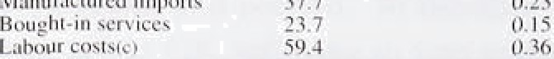

I =' 'iii:irg i ns' x volii my j ? 2.I' {i. 1.1

J'olul lfi2.6. L00



Thus the margins.!of U.K rpanufactur„ing i!ndustry as a whole were!.close to 20% {n,1989. This..is higher than .for intlividual manufacturing firms because wé exclude inputs puréhase‹1 froifi dthér.manufacturers from costs, to avoid .‹rouble counting.

Updating these .figures using price data requires assumptions .to be made about'how firms' use of inputs.i.s affected by .changes. in. their relative prices.. A:ssumifig. firms try to!minimise costs the efféct..will depend .on .how easily inppts:can be su'bstituted..for each othgr: Here it.is assumed that.

.thereiis’no substitutability,: arid productiñity!ga)ns ’pn:ly affect labour iriputs: This means that each input’s cost varies. as a proponion of the value.of output only.according.to rriovemeñts in^its prici. (the. unit lab9ur cost for labour) relative’to the price of output: This assuñiption is more plai:sible in the short run:.

**Measarement**

In.an accounting.sense, changes in output prices may be thought.tif as Ue contribution of margi s plus the change.in the.prices of faitor iñbuts, wliere each factor is yqightrd by„the sh e.of'ts.costs; iq the va:lue of.output

This can be wrinen:

*M Ci*

where AM/ M¿ .is the annual change in profits per

factor *i* in period i, *Z›rjQC¿JC¿¿* is the annual change in weighted factor prices, and *IP JP* is the annual change in output prices. (I -Z›ri¿) is

estimated profits per unit of output in period r.

Using the variable weight method, if ›rJ0 are the weights of each input’s costs in the value of total output in 1989, ›rj¿ are the weights in other years,

then:

*it'* ^i0 ' ***Cit!’ t*** Ci0

where C':o( o) is the input price (output price) in

1989. This method gives the following quarterly

time **series for** manufacturers’ margins. (A shorter

Chart A

Manufacturers

**‹iutput prices‹"'**

Tliis measure has some shortcomings:

*y* output prices may be overrecorded in recession. The CSO asks *ferns* to give actual rather than book prices, but it is possible that some firms do not take discounting, which is common in recessions, fully into account. Thus output prices, and hence margins, may be overrecorded in recession, but increase faster than recorded as

the economy recovers;

not all costs are included. The broadest definition of costs would include the price of all variable factors of production, the user cost ot’

t xed capital and indirect taxes such as business

there are insufficient data for the price of bought-in services to be measured precisely and

on a timely basis. Domestic output deflators for bought-in services are only available on an annual basis; and they represent prices charged to the whole economy rather than to the manufacturing sector. 1992 is the most recent year for which I es is currently available. Quarterly data have been constructed using the annual data and quarterly information on the deflator for GDP excluding North Sea output.

The same series is also used to estimate bought-in costs in the period after 1992;

the price data used are not necessarily consistent with the prices used in constructing the input-output tables; and

the production structures of the domestic and export sectors are not distinguished.

Annual growth rates of input and output prices are reported in Table S.B. These can be weighted to give the percentage contribution of each cost component to the increase in output prices. Table 2 below shows contributions for the year to November 1993.

Table 2

o strong assumptions are made about production COntribulions to iiianu1'avturcrs’ annual ou@ut price tethnologyriamely, fixed coefficients of increases, Novcmher 1993 " '

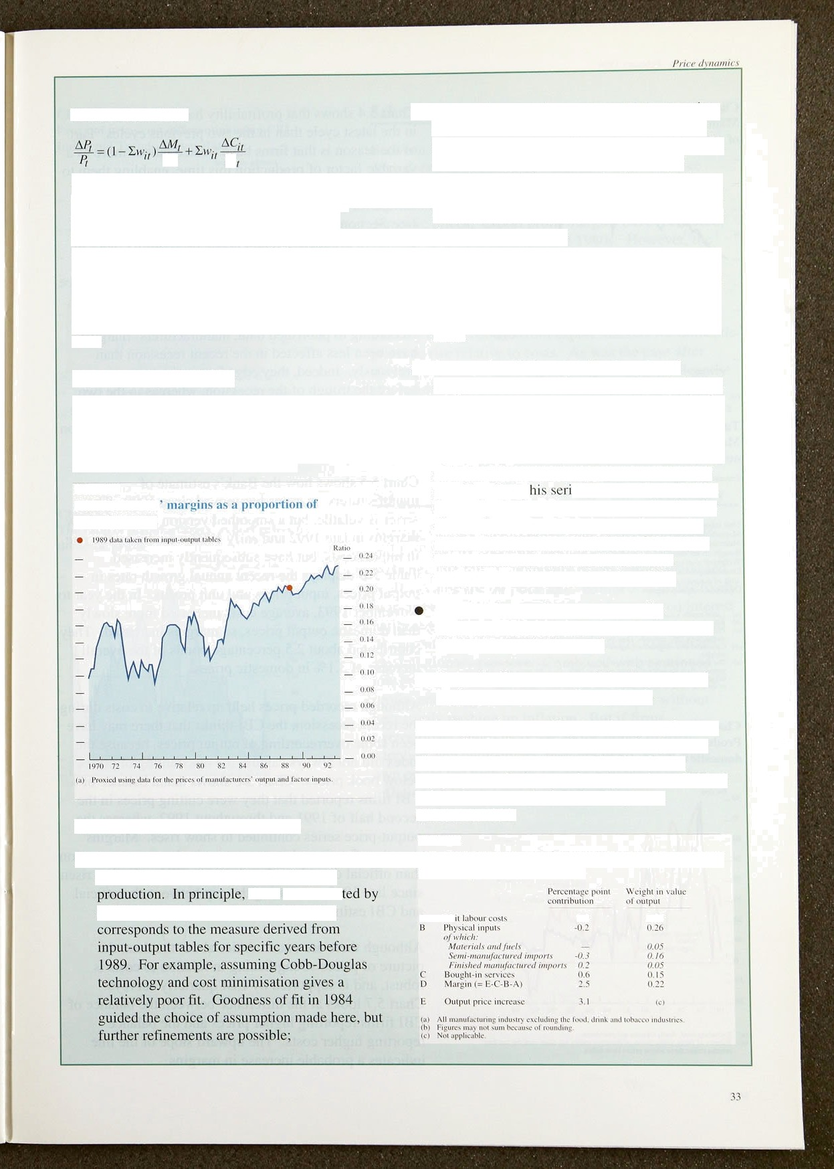

.theae san be tes

seeing how well the estimate.of margins A Un



Chaft S.4 shows. that profitability mas. been less fiol!atile in the latest cycle than in the .two previous:eyc1es. Part. of the .reason is that!firms. have treated.„labour more as a variable factor of produétion this .time, enabl!l.rig them. to. contain labour costs,at a much..earl.ter stage. This has shifted forward the productivity cycle and dampened it: (see Section 4). The corollary .is that there may be less growth in productivity, an‹i hence profitability, later iri. this recovery relative to previous cycles, when profitability continued growiiig stroi:gly for alinost three years after the. trough in GDP.

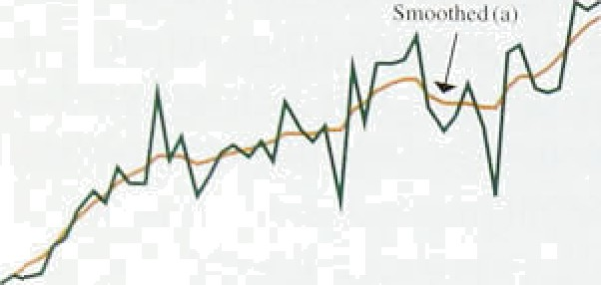



**1t;lnul”a«turing** input **pri«es, unit** prufiL artd ouyput pricrs



Q1 ’’ Q Q3 Od. ’Mwn

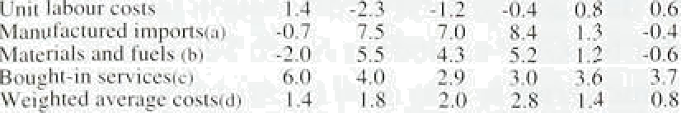



**Producer output price.s«'** and CBI **prices of dtiinestir urders!°'**







34

According to published data, manufacturers’ margins have been less affected in the recent recession than previously. Indeed, they edged up in the two years before the trough of the .recession, whereas i!n .tlie two previous episodes1 they .fell .quite sharply. The meaning and measurement of margins are discussed in.thel box on pages 32-3, where a long-run series is presented.

Chart 5.5 shows how the Bank’s estimate of manufacturers’ margins has moved since 1990. The series is volatile, but a smoothed version illustrates how margins in late 1992 and early 1993 were hit by the rise in import costs, but have subsequently increased.

Table 5.B displays the recent annual growth rates in. output prices, input prices and unit profits. In .the year to November 1993, average costs increased more! slowl.y than domestic output. prices, so margins increased. They contributed about 2.5 percentage points .of the overall Increase of 3.1% in domestic prices.

.Although .recorded prices.held up relative to costs during the .recent recession, the **.CBI** thinks that there may have been some .overrecording of output prices, beeause1the index did not always, capture tlie d!iscounting -of pnces below book prices., Chart!5!.6 shows that a balance of **CBI** firms reported that they were cutting prices. in the second half of f9S.1. arid;tliroughout 1992, whereas’tire output:-price series.continued!.to .show rises. Margi!iis may therefore have been narrower..in the recent recessioq tlian.official.‹rata show but the same CBI series iias'risen

the gap between thé official



sitlce

Although.there are uiicertai.nties about.the.data,. the picture of prices strengthening in relanon to costs' is robust, a:nd is supported by CB.I’ quarterly surveys.,

Chnrt 5.7 looks at the diffemn‹ie betweeñ tire balance.of CBI.firms!:reportii:g liigher prices aim the'.balance

## *P



indicates::a.probable increase in margins.



— 20









78J9’808tB18Z.’84B5%6’8J:88T8B’9O’919293:84



**Chart 5.8**

**The ratio of manufacturers* export prices to domestic prices**

Average over pcik›d —- 100

— — 110

Between 1988 and 1991, profit margins on export sales were depressed relative to the domestic market (see Chart 5.8). Over the last year, after sterling’s depreciation, export prices have risen faster than domestic prices; export profit margins have recovered, but only to the levels of the late 1980s. However, the ratio of export prices to domestic prices remains below its average over the last two decades. These changes mean that, although the restraining influence on UK inflation of low export prices has diminished, there is unlikely to be pressure from export markets for domestic prices to rise relative to costs. As was the case after sterling’s fall in 1992, margins can change significantly as a result of shocks to costs which take time to feed through to prices. But much of the effect of the pound’s depreciation on costs will by now have been passed into

prices.

## 4 S

Average sterling impori prices rose between 1992 Q3 and 1993 Q3 by about the amount that the effective exchange rate fell. Commodity prices hardly increased at all, because the oil price fell. With world prices likely to increase very little on average, and uncovered interest parity suggesting the exchange rate will temain around its current level, .import costs are unlikely to generate any inflationary pressure. Combined with continued

low growth of unit labour costs, this means that firms’ profits and margins can continue to increase without necessarily pushing up inflation. But if firms overestimate future increases in the prices of their suppliers and competitors, they are likely to set their own prices too high, with adverse consequences for inflation and long-term competitiveness.



 



**It PU inf1ati‹›l** ‹›ulj‹irns iH d **pr‹›jecti‹›ns**

Monetary policy is based on an assessment of where inflation is headed.some two years hence. it is this projection which is most relevant to setting monetary policy.

#### The Bank’s medium term inflation

* o e t

**C’hart 6.2**

RPI N’ inflation oulturns and projecliiins





Chart 6.1 shows the Bank’s central projection —the inost likely outcome—for RPIX inflation to the end of 1995 (six months further out than in the last *fiepor/),* together with the actual figures so far and the projection

published in the last *Report.* They are drawn up assuming that base rates are 5 /2%, and that the exchange. rate adjusts to maintain uncovered interest parity. The projection takes into account the news embodied in recent statiStICs, both for inflation itself and for money and.activity. Aggregate demand and .output are recovering and the output gap appears to be falling at an uncertain rate. The chart.shows that a lower rate of RPIX inflation is expeéted than wks tlie,case in

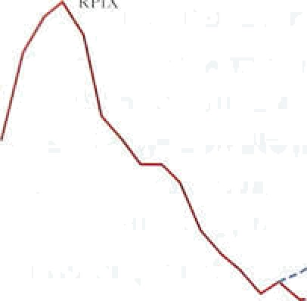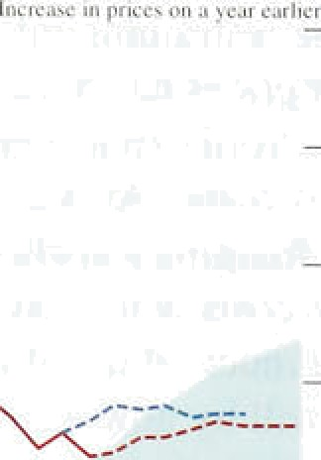

.November, particularly over the first half of:this year. The rate is expected to rise slightly.through 1994; by the end of 1995, the central projection of RPIX'infiation is just over 39c.

Chart 6.2 shows the central projection for RPIY inflation. The gap between RPIX and RPIY inflation projections is larger than in.November, because of.the indirect tax increases announced in the March and November 1993 Budgets. Tlie.se tax .increases with add about half a percentage.point to RPIX inflation,during 1994 and 1995.. Chan 6.2 compares the. Bank’s!

, projection of RPIY inflation. with the projection made three months ago. It shows a larger downward rexision than for RPIX, with annua) RPIY•inflation stabilising at around 2%—3&o from tlie first elf.of.this:ye.ar.

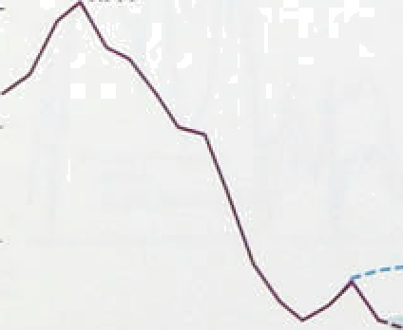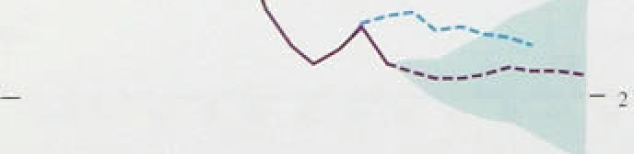

—

- .4

What tiews is.responsi!ble for the revision. in.inflation proj:e.ctions this.quarter? ,The main,!items Ital.e been:

*4.* the surprisingly low o tturesifoi'RPlX and: RPIY 'inflation:::i!niQetober and:Novemtier; which reflect not,.only.: greater competition amotig retailers, .but also sttonger than expected diFinflqtioqary forces in

:,the economy as â whole;



- 14





- - 2

0 ’Q6 12 IN 24 10 Jé tI 4.8 5.4 6,0

Raage of.foiocuis

S‹iuiee: Fnrec, psis;.of 36. pri*,aic seciofi organ iss{ioas ss,of Jiinutuy 1994..

Ckart 6.4

Died ibution of RPIX **inflatcon** forecasts for US Qd



I I



— 4

I

I

—0

0 0.6’ K2.n8. 2.4 10 .3.6 .4J 48 54 6L

*m* th*e* deflationary impact of the November Budget’s tax and spending announcements in the short run;

O confirmation of the recovery in both manufacturing and total output; and

0. .an acceleration of monetary growth.

Taken together, these factors mean that the projection starts from a lower current level of inflation than was anticipated in November, bu1 that underlying inflation is unlikely to fall much further. The recovery of output and employment, and the acceleration of monetary growth,.are likely to reduce downward pressure on inflation. Inflationary expectations still remain above the actual inflation rates that have recently been achieved.

* 1. Private sector **inflation** forecasts

A survey .of forecasts by organisations in the private sector.indicates that expectations of future inflation have fallen further since November. The median expected inflation rate for end-1994 stands at 3'/•% (Chart 6.3).

Chart 6.4 shows the range of expectations at the end of 1995. The market for traditional and index-linked gilts reveals that participants now expect lower inflation over a long-term .horizon than they did in November

(Chart 6.5); expectations are now close to or within the government’s target range over all the next fifteen years. This implies that the credibility of the new framework for monetary policy continues to increase.

SoJo•s Pñiec0ti'iif 30 bnM.arclili.'oiganiwions'.ax:qf Jar'u'aiy l9ii4..



C!iartt6.5

**loflako» tezm structure dertyed I'rom**

d **prices**

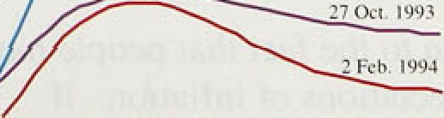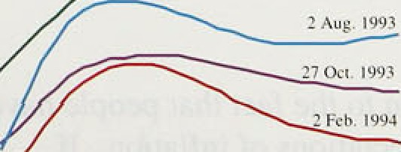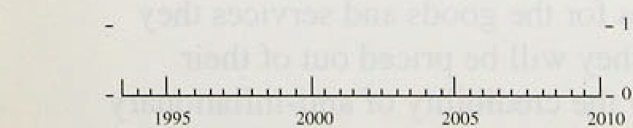

* 1. **Un**n**ce**e**rtain**n**tie**e**s a**a**ffe**e**c**c**tin**n thee **r**r**o’**e**ectio**o**n**n

Since.the February 1993 *Inflation* the



medium-term RPIX projections have been presented as a central forecast plus a range on either side of it. The range is calculated from the average size of past errors in forecasting the consumption price deflator since 1985.

The range has now been recalculated using errors in ecting **RPIX** inflation itself, again since 1985. RPIX



###### fs not Subject to revision and is available sooner than the

:e.onsumption deflator. The forecast errors are comespon‹iingly smaller, and this is reflected in the new

###### .range shown.in Charts 6.1 and 6.2.

ia an **environs**ent of towl and stable inflation,

*I*ortxnsâng inflation should.become.easier; so this range

.inaypaini a.pessimistic picture. Indeed the range

:3;7



exaggerates the uncertainty because the projections are conditional ones based on the assumption.of unchanged. interest rates. Some of the past forecastingterrors have occurred because of subsequent changes in policy. It is not possible to isolate this effect fully, although some 10% of the average forecast error can be attributed to subsequent changes in interest rates.

The new range shown in our charts is based on the analysis of past errors. But it is more .relevant to look at the economic reasons for deviations ,of the outturn from the central projection. There are both upside:and downside risks.

The future behaviour of savings is uncertain. A fall in the personal saving ratio is expected. It could fall further if confidence in the recovery (and an erosion of the debt overhang) is maintained; or it could stay at around its current level if the Budget measures tâking effect in April damage confidence.

The effect of direct.and indirect tax increases on nominal wage claims and settlements is uncertain. There is no hard statistical evidence on how much real pre-tax wage bargains areoaffected by tax increases. Nor is it clear how much .further wage bargainers' inflation expectations: willlfall (which would work in the.opposite direction). The Budget measures and the recetit surprisingly large falls in unemployment. mean‘that there1is a risk that wage increases will prove stronger than expe:cted.

Stockbuilding is always a volatile component of aggregate demand, and sto‹iks remained remarkably low during the re:cent downturn. If corporate confidence continues to improve, there is a risk thai a sudden increase.in stockbuilding could lead to a significant increase in.aggregate demand.

These factors:suggest that the cliances of inflation

.overshooting the central jitojection are.: g ater.than. those of an undershoot.

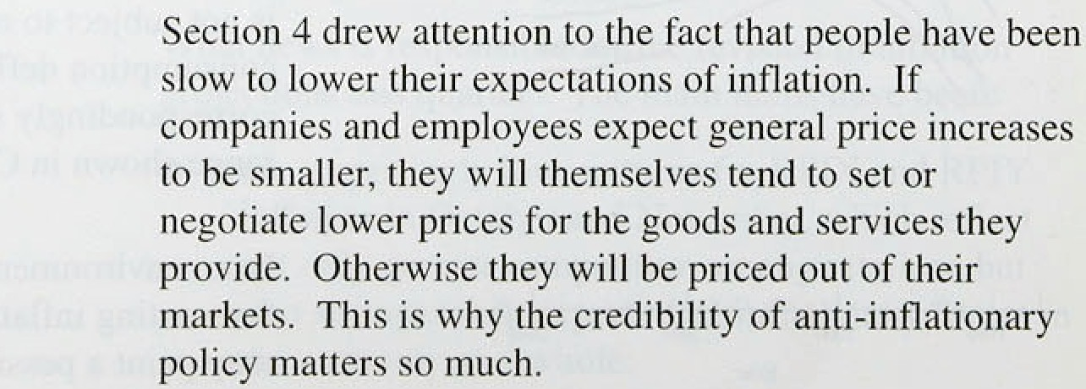



The recent rise in headline inflation was inevitable, because it reflected earlier mortgage interest rate cuts dropping out of the 12-month comparison and higher excise duties. Over the next two months, the gap between RPI and RPIX inflation will largely disappear, with both measures likely to rise further as higher indirect taxes take effect. Nevertheless, inflation has been much lower than anticipated in the November

*Repon.* Measures of inflation which exclude changes in

indirect taKes—such as RPIY—have fallen faster than

expected and are now below 3' o.

Monetary aggregates—narrow, broad and Divisia—have been rising more rapidly than at the time of the November *Report.* Output is growing at or above its trend rate. Unemptoyment has been falling. Taking all these factors together, the Bank’s new central projection is that RPIX inflation will rise slightly during 1994 and remain steady during 1995, ending the year at over 3%. RPIY inflation is projected to stabilise at around 29a—3&o from the middle of 1994.

Projections are often accompanied by a disclaimer that the state of the economy is unusually uncertain. Today there are good reasons to emphasise that point. First, it is difficult to gauge the strength of the current recovery, A significam output gap remains, hut the fall in unemployment and rise in capacity utilisation suggest that it is narrowing. Second, from April this year, there will be a substantial fiscal tightening. It will reduce the PSBR in 1996/97 by.around 3% of GDP and squeeze household disposable incomes by about 3&« over two years or so. To the extent that these increases have already been anticipated, they will not lead to a fall in consumption later in 1994 and 1995, although they may have induced higher spending now on items such as domestic fuel that will rise in price. But, to the extent that higher taxes have not been anticipated, lower

###### di8 D$able income in future will restrain the gmwth in unnsumer spending. Third, some influences that have he1d.back econ:›mic expansion msy have a diminishing efféet in the period ahead: the impact of continuing high levels of pejsqnal debt, tire behaviour nf stockbuilding, ahd in the*butinental Pñ economies.

Thai : «smi at there is considerable unceminty

lnfucionRepvR: Puhruury lgV4 _

about aggregate demand in .1994. Fourth, the. potentia’l reaction of money wages to a slowdown.in the growth of real take-home pay poses a risk to the cpmñination.of continuing output growth and low inflation. .Attempts to restore growth in .real take-home pay would, in the face of a non-accommodating monetary policy, soon lead to higher unemployment, not.higher inflation.

In the Bank’s view, the most likely prospect over the next two years is that output wi!l grow at just above its trend rate and underlying inflation will remain low.

Headline and RPIX inflation will, however, rise to reflect higher indirect taxes, and the latter is likely to remain in the upper half of the target range.

Expectations have yet to adjust to the sharp fall in inflation which has occurred over the past two years. .In these circumstances, the risks to the central projection for inflation are asymmetric—a rise in underlying inflation seems more likely than a further fall. The prospect of continuing low inflation, and a fall into the lower half of the target range. depends on an adjustment of expectations to a low-inflation world. The speed of progress to hlgher levels of output and employment depends on the extent to which everyone involved in decisions on saving and investment, and on wages and prices, are convinced that inflation will indeed be kept down so that they can plan in terms of real—rather than nominal—rates of return and rewards.

